Article

Diversity and Selection of Superior Algarrobos (*Neltuma   
pallida*) Phenotypes in the Natural Dry Forests of Peru for   
Sustainable Conservation and Genetic Improvement

Sebastian Casas-Niño 1,2,*, Juan Rodrigo Baselly-Villanueva3, Evelin Judith Salazar-Hinostroza 4,   
Sheyla Yanett Chumbimune-Vivanco 4, William Nauray5, Nery TirabanteTerrones 6, Max Ramirez Rojas 1   
and Flavio Lozano-Isla 1,7,*

1Dirección de Servicios Estratégicos Agrarios, Estación Experimental Agraria El Chira, Instituto Nacional de Innovación Agraria (INIA), Piura 20120, Peru; proyectochira@inia.gob.pe

2Facultad de Ciencias Forestales*,* Universidad Nacional Agraria La Molina (UNALM), Lima, Peru

3Estación Experimental Agraria San Roque, Instituto Nacional de Innovación Agraria (INIA), Calle San   
Roque 209, San Juan Bautista, Loreto 16000, Peru

4Dirección de Investigación y Desarrollo Tecnológico, Instituto Nacional de Innovación Agraria (INIA), Lima, Peru; jbaselly@inia.gob.pe (J.R.B.-V.); esalazar@inia.gob.pe (E.J.S.-H.);   
20081043@lamolina.edu.pe (S.Y.C.-V.)

5Dirección de Estudios e Investigación, Servicio Nacional Forestal y de Fauna Silvestre, Lima, Peru;   
wnauray@serfor.gob.pe

6Laboratório de Genoma Funcional, Departamento de Genética, Evolução, Microbiologia e Imunologia, Instituto de Biologia*,* Universidade Estadual de Campinas, Caixa Postal 6109, Campinas 13083-970, Brazil;   
nery@lgf.ib.unicamp.br

7Facultad de Ingeniería y Ciencias Agrarias, Universidad Nacional Toribio Rodríguez de Mendoza de   
Amazonas (UNTRM), Amazonas 01001, Peru

**\*** Correspondence: 20140231@lamolina.edu.pe (S.C.-N.); flavio.lozano@untrm.edu.pe (F.L.-I.)

**Abstract**

|  |
| --- |
| Academic Editor: Mario A. Pagnotta  Received: 13 October 2025  Revised: 5 November 2025  Accepted: 6 November 2025  Published: date  **Citation:** Casas-Niño, S.; Baselly- Villanueva, J.R.; Salazar-Hinostroza, E.J.; Chumbimune-Vivanco, S.Y.; Naurai, W.; Terrones, N.T.; Rojas, M.R.; Lozano-Isla, F. Diversity and Selection of Superior Algarrobos (*Neltuma pallida*) Phenotypes in the Natural Dry Forests of Peru for  Sustainable Conservation and  Genetic Improvement. *Diversity* **2025**, *17*, x. https://doi.org/10.3390/xxxxx  **Copyright:** © 2025 by the authors. Submitted for possible open access publication under the terms and conditions of the Creative Commons Attribution (CC BY) license (https://creativecommons.org/licenses/by/4.0/). |

*Neltuma pallida* (algarrobo) is a keystone species of the Peruvian dry forest whose persistence is threatened by overexploitation and habitat degradation, making its conservation and genetic improvement a national priority. This study aimed to identify outstanding phenotypes of *N. pallida* through phenotypic characterization in the regions of Piura and Tumbes in northern Peru. A stratified random sampling design was applied, establishing forest plots in 13 localities and evaluating 631 adult individuals. Dendrometric and phenotypic traits were recorded together with physiographic, climatic, and edaphic variables obtained from soil analyses and geographic information systems. Phenotypic differentiation among populations was assessed using the index $P_{ST}$, which quantifies between- and within-population variance components. High morphological variability was detected across populations, with significant differences in tree height, diameter, and fruit production, largely explained by environmental heterogeneity, particularly soil fertility and organic matter. The $P_{ST}$ values, ranging from 0.83 to 0.98, revealed strong phenotypic divergence among populations, suggesting adaptive differentiation rather than neutral variation. Eight superior individuals were identified as potential candidates for inclusion in a germplasm bank to support breeding and restoration programs. This study provides a scientific basis for the sustainable management and conservation of *N. pallida* in the arid ecosystems.

**Keywords:** biometry; conservation; ecology; genetic improvement; soil characterization

1. Introduction

*Neltuma pallida*, commonly known as algarrobo, belongs to the genus *Neltuma,* previously classified within *Prosopis* [1]. It is recognized as a valuable forest resource in arid and semi-arid regions [2] due to its ability to fix atmospheric nitrogen in soils [3], its longevity, and its durable hardwood of high economic value [4]. From an ecological perspective, algarrobo enhances soil fertility and moisture retention, moderates extreme conditions by creating microclimates beneath its canopy [5], and contributes to the stabilization of fragile desert ecosystems through processes of desalination and microclimatic amelioration [4]. In addition, the species plays a role in climate change mitigation through atmospheric carbon sequestration [6].

In Peru, it is mainly distributed within the Equatorial Dry Forest, which occupies approximately 3.45% of the national territory and represents about 61% of the vegetation cover of dry ecosystems [7]. This biome extends primarily across the departments of La Libertad, Lambayeque, Piura, and Tumbes [8], where the species constitutes an essential structural and functional component. However, these northern Peruvian regions have been severely affected by deforestation and land-use change processes [9], resulting in pronounced habitat fragmentation and a reduction in natural populations of *N. pallida* (algarrobo). Given this scenario, monitoring and conservation actions have become imperative [9], especially since algarrobo has been declared a priority species for research, conservation, and protection by the Peruvian government [10]. In this context, genetic and morphological characterization studies are critical, as they allow for the precise distinction of species or local ecotypes and the design of conservation strategies focused on populations with higher adaptive value or greater risk of extinction [11]. Achieving adequate characterization requires the evaluation of both quantitative and qualitative attributes. Beseega et al. [12] emphasized that individual selection has major implications for genetic resource management and that adaptive phenotypic traits, as well as population origin, should be carefully considered before initiating any selection program. In this regard, phenotypic evaluation is a key step in identifying superior trees [13]—individuals with superior phenotypes in one or more economically important traits that may serve as progenitors in genetic improvement and conservation programs [14–16]. In general, traits selected for breeding should (a) exhibit strong genetic control, (b) display high genetic variation, and (c) preferably be easy to measure [17].

The selection of superior individuals in multipurpose tree species such as *N. pallida* is particularly challenging, as highlighted by Alban et al. [18] who noted that selecting trees for multiple uses is inherently more complex than for single-purpose species, such as those used for timber or pulp. In this species, a well-branched crown structure is essential to ensure high pod yield. The fruits of *N. pallida* play a vital role as food resources for both humans and livestock in arid and semi-arid regions [19]. In the dry forest ecosystem, the pods of *N. pallida* are especially valued as nutritious forage, serving as a critical feed source for cattle and goats during the dry season, when fresh forage availability is limited [20]. Given their nutritional and economic significance, optimizing pod production and enhancing pod quality are crucial strategies to support local livelihoods.

The effectiveness of phenotypic characterization and tree selection is supported by numerous studies, where phenotypically outstanding trees for one or more economically valuable traits [15] have been successfully used for both conservation and genetic improvement [21,22]. Complementary work by López et al. [23] on *Neltuma alba* under drought stress demonstrated the relevance of functional intraspecific diversity and local adaptation, identifying distinct physiological strategies of drought tolerance linked to leaf morphological traits and genetic variation. These findings reinforce the need to prioritize provenances adapted to changing environmental conditions, as understanding the mechanisms underlying adaptive variation is important for developing resilient forest populations.

In this context, evolutionary inference based on the comparison between genetic and phenotypic differentiation among populations represents a powerful approach to elucidate local adaptation processes in forest species [24]. Traditionally, the degree of quantitative genetic divergence across populations is estimated using $Q_{ST}$, which is compared with neutral genetic differentiation ($F_{ST}$) to infer the action of natural selection [25]. However, estimating $Q_{ST}$ requires controlled breeding designs or common-garden experiments, which are often unfeasible for ecologically important or conservation-priority forest species [26]. In such cases, $P_{ST}$, derived from phenotypic divergence among natural populations, provides a practical surrogate for $Q_{ST}$ [26]. This phenotypic-based approach enables robust evolutionary inference when additive genetic information is lacking, allowing the identification of selection patterns and local adaptation across heterogeneous landscapes where environmental gradients impose contrasting selective pressures and population structure shapes the evolutionary response of functional traits.

Despite its ecological and productive significance, *N. pallida* (Humb. & Bonpl. ex Willd.) Hughes & G.P. Lewis [1] still lacks integrated studies addressing phenotypic characterization, local adaptation, and identification of superior trees in natural populations. To address this gap, the present study aims to characterize algarrobo (*N. pallida*) in populations from Piura and Tumbes, through the evaluation of phenotypic traits, edaphoclimatic conditions, and heritability estimates, with the objective of identifying trees with potential for inclusion in future genetic improvement and conservation programs.

2. Materials and Methods

2.1. Study Area

The evaluations of qualitative and quantitative traits of *N. pallida*, a native tree species that grows naturally in dry forest ecosystems, were conducted in 13 localities distributed across the departments of Piura and Tumbes, in northwestern Peru (Figure 1). In Tumbes, sampling was carried out in the districts of Zorritos (Contralmirante Villar Province), San Jacinto, and Corrales (Tumbes Province), encompassing the localities ISA REP, Pedregal, and Bosque Marginal (Zorritos), Rica Playa (San Jacinto), and INIA (Corrales). In Piura, the evaluations were performed in the districts of Marcavelica and Sullana (Sullana Province), La Matanza and Chulucanas (Morropón Province), and Veintiséis de Octubre (Piura Province). The localities considered were Fundo Valdez (Sullana), Saman Chico (Marcavelica), SENASA and CC Ignacio Távara (Chulucanas), Kurt Beer (Veintiséis de Octubre), and Km 190, Chamchape, and Monte Azul (La Matanza).

Both departments are located within the tropical dry forest ecoregion [7], the natural habitat of *N. pallida.* Piura lies between 4°05′ and 6°22′ S latitude and 79°00′ and 81°07′ W longitude. In the study sites of this department, the average maximum temperature reaches 38.1 °C, while the mean minimum temperature is 15.7 °C. Rainfall is seasonal and scarce, with an annual average of 226.7 mm [27]. Tumbes is situated further north, between 3°22′56.81″ and 4°19′3.48″ S latitude and 80°2′46.90″ and 80°7′37.43″ W longitude. Study sites in this region recorded an average maximum temperature of 37.5 °C and a mean minimum of 17.7 °C. As in Piura, rainfall is seasonal, but with higher accumulation, reaching an annual mean of 324.5 mm [27].

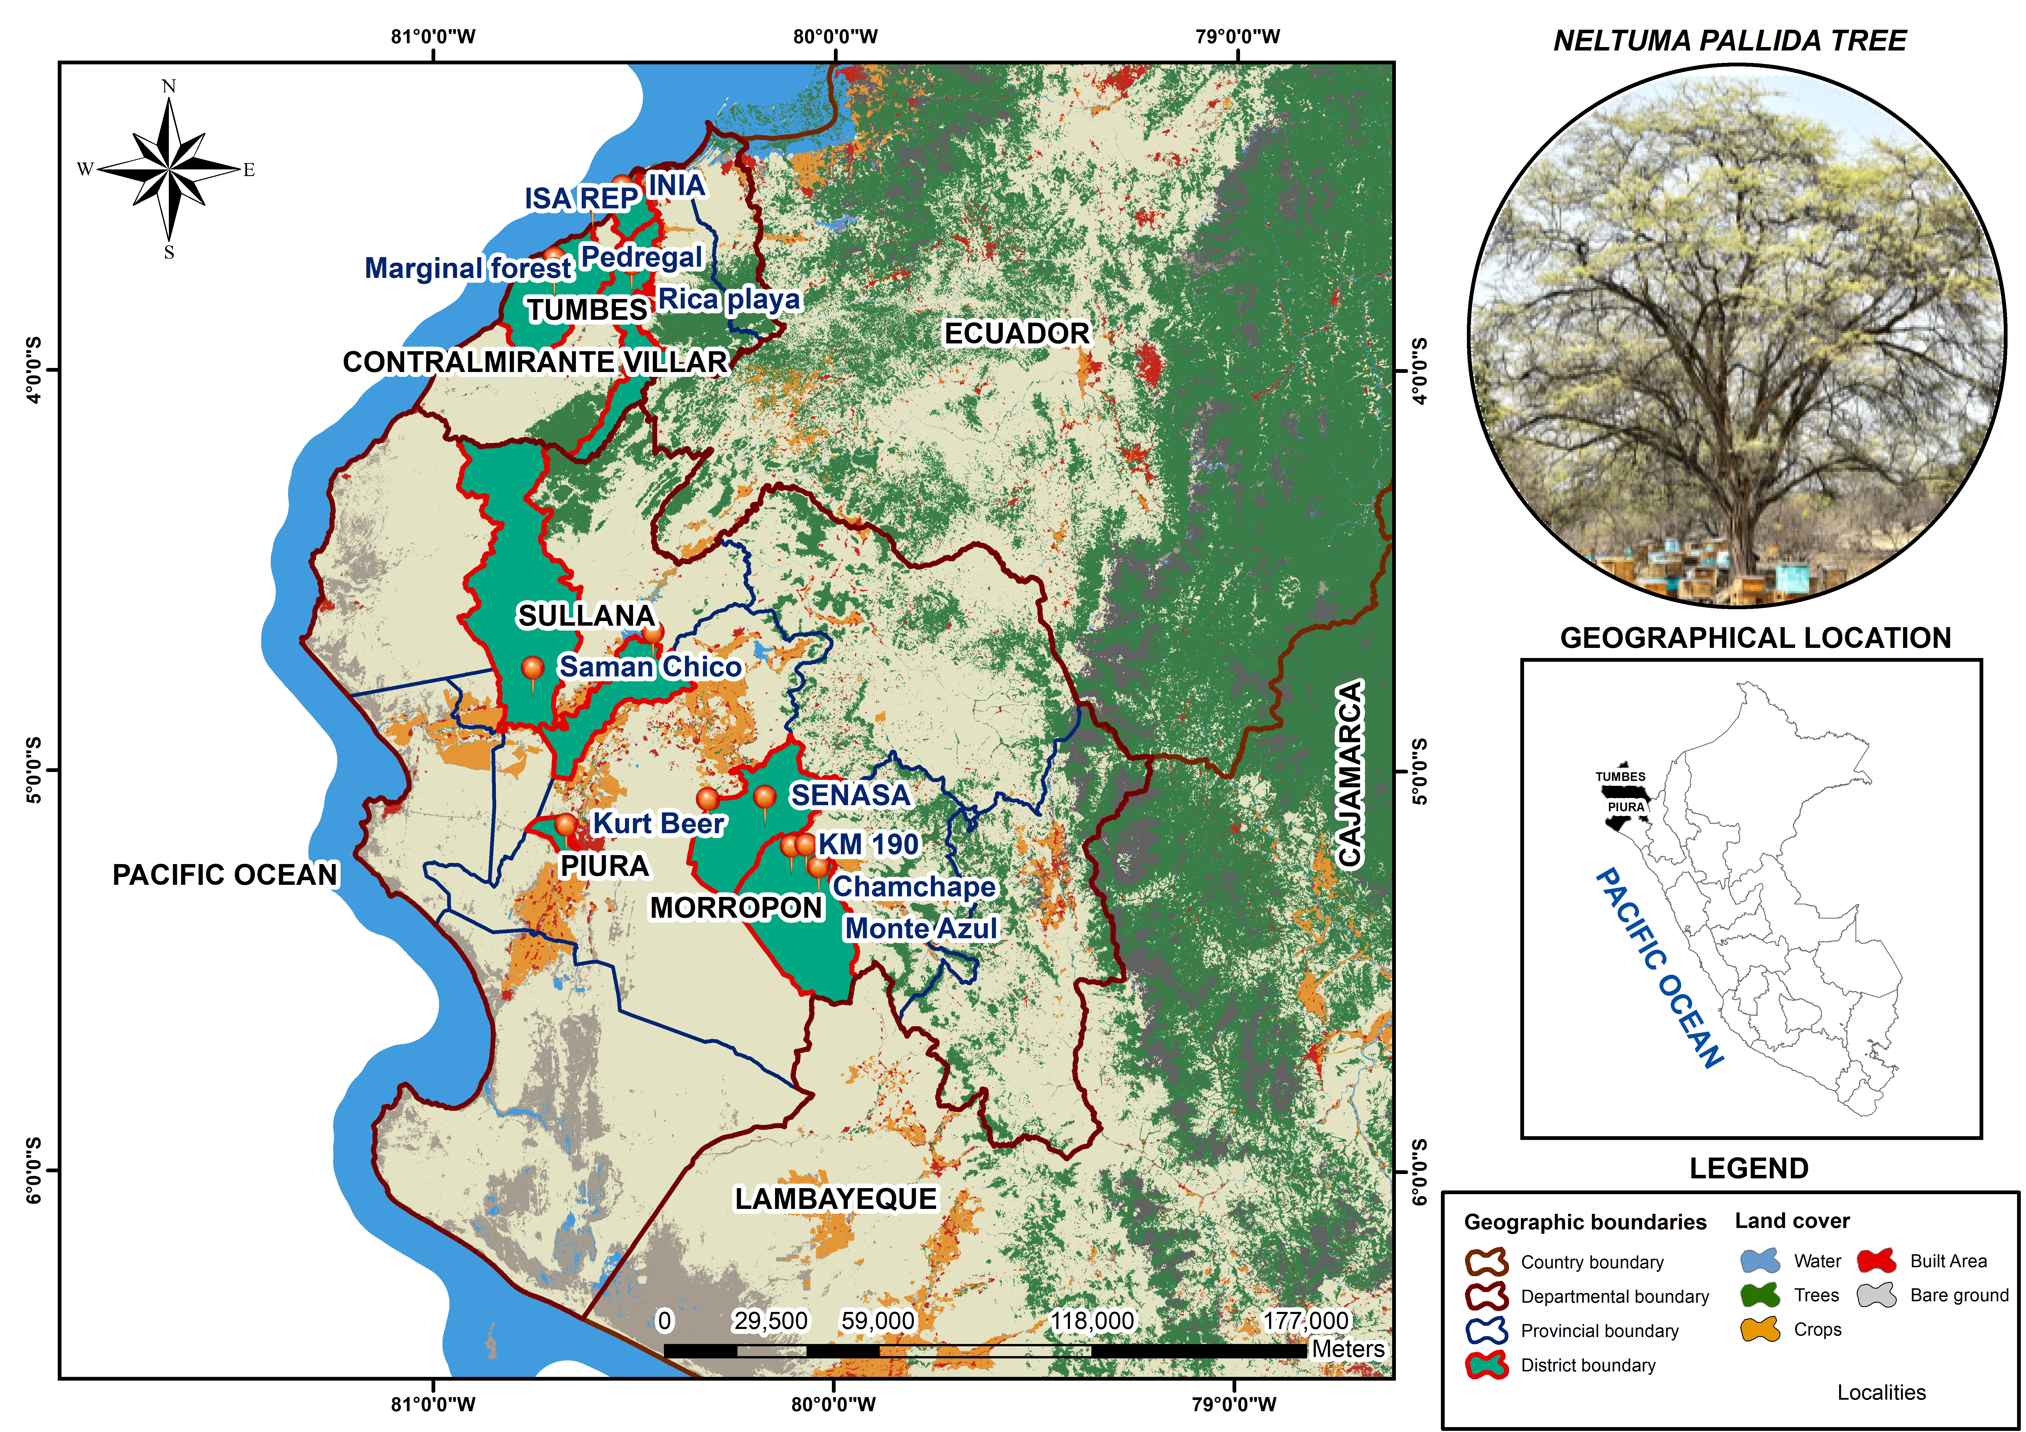

**Figure 1.** Geographic distribution of the 13 study sites where *N. pallida* was evaluated in Piura and Tumbes, northwestern Peru.

2.2. Tree Sampling Methodology

A stratified random sampling design was employed, established according to the ecosystem types present in the study area based on the Ecosystem Map of Peru [28]. Two main strata were identified: seasonally dry lowland forest and seasonally dry riparian forest. Within each stratum, sampling plots were installed in localities that exhibited relatively homogeneous habitat conditions. In these areas, sampling units were randomly selected, prioritizing zones with higher individual density and greater canopy cover to represent the most structurally developed portions of the forest. The number of plots per stratum was determined according to habitat variability and site accessibility. Areas were considered suitable when they contained trees taller than 5 m with canopy cover greater than 10%, or when they included individuals with the potential to reach these parameters under in situ conditions [29].

The sampling unit consisted of a 0.5 ha forest plot (5000 m2), which corresponds to the area recommended for forest inventories in dry forests of Peru’s coastal region [30]. Each plot measured 250 m × 20 m, following established technical criteria. Within each plot, 10 subplots of 50 m × 10 m were delineated, where all individuals with a diameter at breast height (DBH) ≥ 10 cm were recorded [31]. The evaluation included both adult trees and saplings, and their main morphological and phenotypic characteristics were recorded. In total, 631 individuals were evaluated.

2.3. Edaphoclimatic Data Collection

Soil variables were collected directly in the field. Prior to soil sampling, an exploratory survey was conducted in each study area to identify homogeneous zones in terms of relief, surface color, texture, and land-use type. Based on this preliminary characterization, a random sampling design was applied following a zigzag pattern. At each sampling point (every 15–30 steps), a subsample was extracted with a shovel at a uniform depth of 20–30 cm according to the root depth. For each hectare, between 20 and 30 subsamples were collected and deposited in a clean plastic bucket, mixed thoroughly, and homogenized to form a composite sample [32]. The mixture was subsequently quartered until an approximate volume of 1 kg was obtained. During this process, visible residues of fresh organic matter, stones, and gravel were removed. The final sample was stored in a double clean plastic bag, properly labeled with essential information (identification code, geographic location, sampling date) and hermetically sealed. Samples were then transported to the laboratory for subsequent physicochemical analysis.

Soil chemical analyses were conducted in accordance with the Mexican Official Standard NOM-021-RECNAT-2000 [33], which establishes the specifications for soil fertility, salinity, and classification studies. The equivalent calcium carbonate content was determined using the AS-29 method, based on acid neutralization. Electrical conductivity was measured in the saturation extract with a conductivity meter, following the AS-18 method. Available phosphorus in neutral and acidic soils was quantified by the AS-11 method, following the Bray and Kurtz procedure. Soil organic matter was determined according to the AS-07 method of Walkley and Black, while total nitrogen was analyzed using the AS-25 method, through soil digestion. Available potassium was extracted with 1 mol L−1 ammonium acetate solution at pH 7.0 and quantified by atomic absorption and emission spectrophotometry, using lanthanum as a stabilizing agent. Finally, soil pH was determined in aqueous suspension by potentiometric measurement, following the procedures established by the standard.

Climatic variables were obtained from NASA’s Prediction Of Worldwide Energy Resources [27] database, accessed on 22 July 2025. The geographic centroid of each evaluated plot was used as a reference point for data extraction, considering the period 2015–2024 for analysis. Physiographic variables were derived from Geographic Information Systems (GIS): slope and elevation were extracted from a Digital Elevation Model (DEM) with a spatial resolution of 12.5 m, while distance to water bodies was estimated using Euclidean distance from Peru’s official hydrographic network (Table 1).

**Table 1.** Description of the edaphoclimatic characteristics of the study localities distributed across the departments of Piura and Tumbes. CaCO3: calcium carbonates; EC: electrical conductivity; P: phosphorus; OM: organic matter; N: nitrogen; K: potassium; pH: hydrogen potential; CS: incoming solar radiation; pp: precipitation; RH: relative humidity; Tmean: mean temperature; WS: wind speed; Tmax: maximum temperature; Tmin: minimum temperature; SLI: elevation above sea level; Slope: slope; DW: Euclidean distance to water bodies.

|  |  |  |  |  |  |
| --- | --- | --- | --- | --- | --- |
|  | **Variable** | **Minimum** | **Maximum** | **Mean** | **Deviation** |
| Edaphic | CaCO3 (%) | 0.09 | 2.1 | 1.03 | 0.7 |
|  | EC (dS/m) | 0.03 | 7.69 | 0.78 | 2.08 |
|  | P (ppm) | 8.42 | 250.1 | 84.88 | 94.85 |
|  | OM (%) | 0.19 | 6.7 | 2.29 | 2.31 |
|  | N (%) | 0.03 | 0.2 | 0.09 | 0.04 |
|  | K (ppm) | 11.1 | 1321.13 | 415 | 396.57 |
|  | pH | 5.59 | 8.68 | 7.37 | 1.01 |
| Climatic | CS (MJ/m2/day) | 11.2 | 11.4 | 11.32 | 0.09 |
|  | pp (mm/year) | 190.8 | 495.6 | 264.31 | 86.83 |
|  | RH (%) | 60.4 | 73.1 | 62.59 | 3.33 |
|  | Tmean (°C) | 22.9 | 26.3 | 25.25 | 0.97 |
|  | WS (m/s) | 2.1 | 4 | 3.18 | 0.66 |
|  | Tmax (°C) | 31.4 | 39.3 | 37.85 | 2.15 |
|  | Tmin (°C) | 14 | 20.4 | 16.45 | 1.49 |
| Physiographic | SLI (m) | 5 | 180 | 71.08 | 50.16 |
|  | Slope (%) | 0.33 | 5.13 | 2.61 | 1.49 |
|  | DW (m) | 14.17 | 2817.37 | 751.48 | 894.24 |

2.4. Phenotypic Evaluation

Each evaluated tree was assigned a sequential identification number based on the order of registration within the plot. This number was recorded in the field form and served as a unique code for all subsequent measurements. Following an adaptation of the criteria established by Alban et al. [18], data were collected on dendrometric and phenotypic variables. Tree heights were measured using hypsometers, while DBH and crown diameters were measured with metric tapes.

The recorded variables included: total tree height (m); height of the first branching (m); diameter at breast height (DBH, cm), measured at 1.30 m above ground level with adjustments for tree morphology (e.g., bifurcations, sloping terrain); and crown diameter (m), calculated from the average of the longest and shortest crown diameters. In addition, qualitative traits were evaluated, including tree form, stem quality, branching pattern, fruit production, fruit quality, and foliage quality. Fruit quality was evaluated using pods at a uniform stage of physiological maturity, collected during the same phenological period. This approach minimized variation associated with sampling time. In addition, fruit quality was evaluated organoleptically through a sensory test, a reliable approach for assessing quality differences under field conditions [34–36].

2.5. Identification of Superior Trees

The selection of superior trees was based on an integrative approach that considered both quantitative and qualitative attributes. A scoring system was established using rank ranges for each type of variable in order to identify individuals with outstanding phenotypic traits. For qualitative variables, individuals that scored greater than or equal to three on the evaluation scale (Table 2) were selected. For quantitative variables, individuals with the highest values were prioritized (Table 3). Any tree that exhibited at least one unfavorable characteristic (scores ≤ 1) was excluded from the selection process, as it did not meet the minimum criteria for consideration as superior genetic material.

The selection objective for *N. pallida* focuses on pod production, in contrast to timber species, where a straight, unbranched stem is prioritized [18]. In *N. pallida* broad and well-branched crowns are valued, as they promote greater fruit production. This type of selection is more complex due to the trade-off between vegetative growth and pod yield. Therefore, traditional dasometric measurements were combined with a visual assessment based on verifiable criteria to identify individuals with the highest productive potential [18].

Younger trees were not considered, as their development is strongly influenced by other growth variables. Consequently, juvenile individuals were not classified as suitable for this selection process [15].

**Table 2.** Qualitative evaluation scale of morphological and functional traits in *N. pallida* individuals, following the criteria of Alban et al. [18].

|  |  |
| --- | --- |
| **Variable** | **Evaluation Criteria** |
| Tree form | 1 = Multi-stemmed (<1.2 m) with branches >30° |
|  | 2 = Intermediate |
|  | 3 = Single stem (<1.2 m) with branches ≤30° |
| Trunk quality | 1 = Defective |
|  | 2 = Fair with defects |
|  | 3 = No defects or only minor defects |
| Forking | 1 = Below DBH |
|  | 2 = At DBH |
|  | 3 = No branching |
| Fruit production | 0 = No fruits |
|  | 1 = Up to 25% of the branches |
|  | 2 = Up to 50% |
|  | 3 = Up to 75% |
|  | 4 = Up to 100% |
| Fruit quality | 0 = Very bitter |
|  | 1 = Bitter |
|  | 2 = Sweet |
|  | 3 = Very sweet |
| Foliage quality | 1 = Foliage on up to 1/3 of the branches |
|  | 2 = Up to 2/3 of the branches |
|  | 3 = Full foliage on all branches |

**Table 3.** Scoring ranges for quantitative variables used in the selection of *N. pallida* superior tree candidates.

| **Variable** | **Score Ranges** |
| --- | --- |
| Diameter at breast height (DBH) (cm) | 1 = 10–35 cm |
|  | 2 = 36–60 cm |
|  | 3 = 61–85 cm |
|  | 4 = >86 cm |
| Total height (m) | 1 = 4.0–9.0 m |
|  | 2 = 9.1–14.0 m |
|  | 3 = 14.1–19.0 m |
|  | 4 = 19.1–24.0 m |
|  | 5 = 24.1–29.0 m |
| Branch height (m) | 1 = 0–2.0 m |
|  | 2 = 2.1–4.0 m |
|  | 3 = 4.1–6.0 m |
|  | 4 = 6.1–8.0 m |
|  | 5 = >8.1 m |
| Crown diameter (m) | 1 = 0–5.0 m |
|  | 2 = 6.0–10.0 m |
|  | 3 = 11.0–15.0 m |
|  | 4 = 16.0–20.0 m |
|  | 5 = >21 m |

2.6. Assess Population Differentiation in Phenotypic Traits

The phenotypic differentiation among the 13 populations of *N. pallida* by estimating the phenotypic divergence index $P_{ST}$, an analog of the quantitative genetic differentiation index $Q_{ST}$. The methodological framework followed Brommer [26] and was implemented using the *Pstat* 1.2R package [37], which allows the estimation of $P_{ST}$, the exploration of its sensitivity to the ratio $c/h^{2}$, and its comparison with the neutral genetic differentiation index $F_{ST}$.

Prior to statistical analysis, all phenotypic variables were normalized to remove size-related effects through the Aitchison log-ratio transformation [38], which maintains the dimensionality of the dataset and ensures comparability among individuals and populations. For each individual *i* and trait *j*, the transformation was expressed as:

|  |  |
| --- | --- |
| $$Y_{ij}=log\left(y_{ij}\right)-\frac{1}{p}\sum_{k=1}^{p}{log}\left(y_{ik}\right)$$ |  |

where $y_{ij}$ is the original measurement of the $j^{th}$ trait, $p$ is the total number of traits, the $k^{th}$ trait is the explanatory variable, and $Y_{ij}$ is the size-corrected value. This procedure was implemented with the function AitTrans() from the *Pstat* R package.

The variance component estimation between- and within-population variance components $(σ_{B}^{2}$ and $σ_{W}^{2})$ were estimated using a one-factor linear mixed model, with population as a random effect:

|  |  |
| --- | --- |
| $$y_{ij}=μ+P_{i}+ε_{ij}$$ |  |

where $y_{ij}$ is the observation of the $j^{th}$ individual in population $i$, $μ$ is the overall mean, $P_{i}$ is the random population effect, and $ε_{ij}$ is the residual error. Variance components were extracted from model decomposition using restricted maximum likelihood (REML) and later used for the calculation of $P_{ST}$.

Phenotypic differentiation among populations was quantified using the expression derived from Spitze [39] and Brommer [26]:

|  |  |
| --- | --- |
| $$P_{ST}=\frac{c,σ_{B}^{2}}{c,σ_{B}^{2}+2h^{2}σ_{W}^{2}}$$ |  |

where $c$ is the proportion of the total between-population variance attributed to additive genetic effects and $h^{2}$ is the narrow-sense heritability. Because these genetic parameters are generally unknown for *N. pallida*, the equation was reformulated in terms of the ratio $c/h^{2}$:

|  |  |
| --- | --- |
| $$P_{ST}=\frac{\left(c/h^{2}\right),σ_{B}^{2}}{\left(c/h^{2}\right),σ_{B}^{2}+2σ_{W}^{2}}$$ |  |

The ratio $c/h^{2}$ describes the sensitivity of $P_{ST}$ to uncertainty in genetic parameters and was explored over a conservative range from 0 to 3, consistent with heritability estimates reported for arid-zone tree species ($h^{2}≈0.2-0.5$) and range proposed by Brommer [26].

For each trait, $P_{ST}$ values were computed using 1000 bootstrap resamples to obtain 95% confidence intervals. The functions Pstat() and TracePst() from the *Pstat* package were used to estimate and visualize $P_{ST}$ across the range of $c/h^{2}$.

Interpretation followed the classical comparative framework of Merilä and Crnokrak [40]. When $P_{ST}>F_{ST}$, phenotypic divergence was inferred to result from divergent or local selection; when $P_{ST}≈F_{ST}$, differentiation was considered compatible with neutral drift; and when $P_{ST}<F_{ST}$, stabilizing selection was inferred. The robustness of these inferences was evaluated by determining the critical ${\left(c/h^{2}\right)}_{\text{crit}}$ value at which the confidence intervals of $P_{ST}$ and $F_{ST}$ overlapped, as proposed by Brommer [26]. Traits showing $P_{ST}$ values significantly higher than $F_{ST}$ under conservative assumptions ($c≤h^{2}$) were interpreted as candidates for adaptive divergence.

2.7. Data Processing and Statistical Analysis

All statistical analyses and graphical outputs were conducted in R software, version 4.5.0 [41]. The coding workflow, data analysis, and computational environment were implemented in Quarto [42], an integrated system for scientific writing and data analysis (Supplementary Materials).

For multivariate analyses, data were standardized (mean = 0; variance = 1) to homogenize variable scales and reduce bias from differing units of measurement [43]. Principal component analysis (PCA) was employed to explore multivariate relationships among edaphoclimatic variables and localities, as well as among phenotypic variables, localities, and individuals. PCA was performed using the packages *FactoMineR 2.12* [44] and *factoextra 1.0.7* [45].

Phenotypic diversity of qualitative variables was quantified using the Shannon–Weaver diversity index (H′), implemented with the *vegan 2.7-2* package [46]. Quantitative variables were analyzed using one-way analysis of variance (ANOVA), and group mean comparisons were conducted with Tukey’s HSD test at a significance level of α = 0.05, implemented through the *emmeans 2.0.0* package [47]. To identify patterns in the multivariate data and visualize similarity structures among localities, hierarchical heatmaps were generated using the *heatmaply 1.6.0* package[48]. Prior to visualization, data were column-normalized, and hierarchical dendrograms were constructed using Euclidean distance matrices.

To evaluate population differentiation in phenotypic traits, the *Pstat 1.2* package [49] was employed to calculate and visualize $P_{ST}$ values. This package estimates differentiation among populations based on phenotypic variance components, providing bootstrapped distributions and confidence intervals for .

3. Results

3.1. Edaphoclimatic Characterization

The principal component analysis (PCA) showed that the first two components jointly explained 59.40% of the total variability of the system, with 39.90% corresponding to the first component (Dim 1) and 19.50% to the second component (Dim 2). In Dim 1, the variables with the highest contribution were Hydrogen potential (pH) (12.40%), Calcium carbonate (CaCO3) (11.22%), and Phosphorus (P) (11.12%). In Dim 2, the greatest contributions came from Maximum temperature (Tmax) (23.67%), Precipitation (pp) (21.54%), and Relative humidity (RH) (20.37%).

In the factorial plane, the edaphic variables Nitrogen (N), Phosphorus (P), Potassium (K), and Organic matter (OM) exhibited a positive association with each other and were projected toward the positive quadrant of Dim 1. In contrast, pH and Calcium carbonate (CaCO3) were oriented in the opposite direction, indicating a negative relationship with the former variables. Among the climatic variables, Minimum temperature (Tmin), Precipitation (pp), and Relative humidity (RH) shared a common orientation, whereas Incident solar radiation (CS) was aligned toward the opposite region. Regarding the physiographic variables, no clear pattern of association was observed.

The spatial distribution of localities reflected distinct environmental gradients. Monte Azul and Chanchape clustered in the region associated with higher contents of N, P, K, and OM. Conversely, Rica Playa, Pedregal, and Marginal forest were located near the vectors of pH and CaCO3, suggesting soils with greater alkalinity and carbonate content. Along the climatic gradient, Rica Playa, Pedregal, and Marginal forest were associated with higher values of precipitation (pp), Tmax, Tmin, and (Mean temperature) Tmean. Relative humidity (RH) was lowest in Rica Playa, Pedregal, and Marginal forest, while Monte Azul and Chanchape displayed intermediate values. The CS was higher in Monte Azul and Chanchape but lower in Rica Playa, Pedregal, and Marginal forest.

Regarding physiographic characteristics, Pedregal, KM 190, and Fundo Valdez were located closer to water bodies (DW), whereas Kurt Beer, Chanchape, and SENASA were situated at greater distances. The highest elevations (SLI) were recorded at CC Ignacio Távara, KM 190, and Monte Azul, in contrast to Pedregal and INIA, which were positioned at lower elevations (Figure 2).

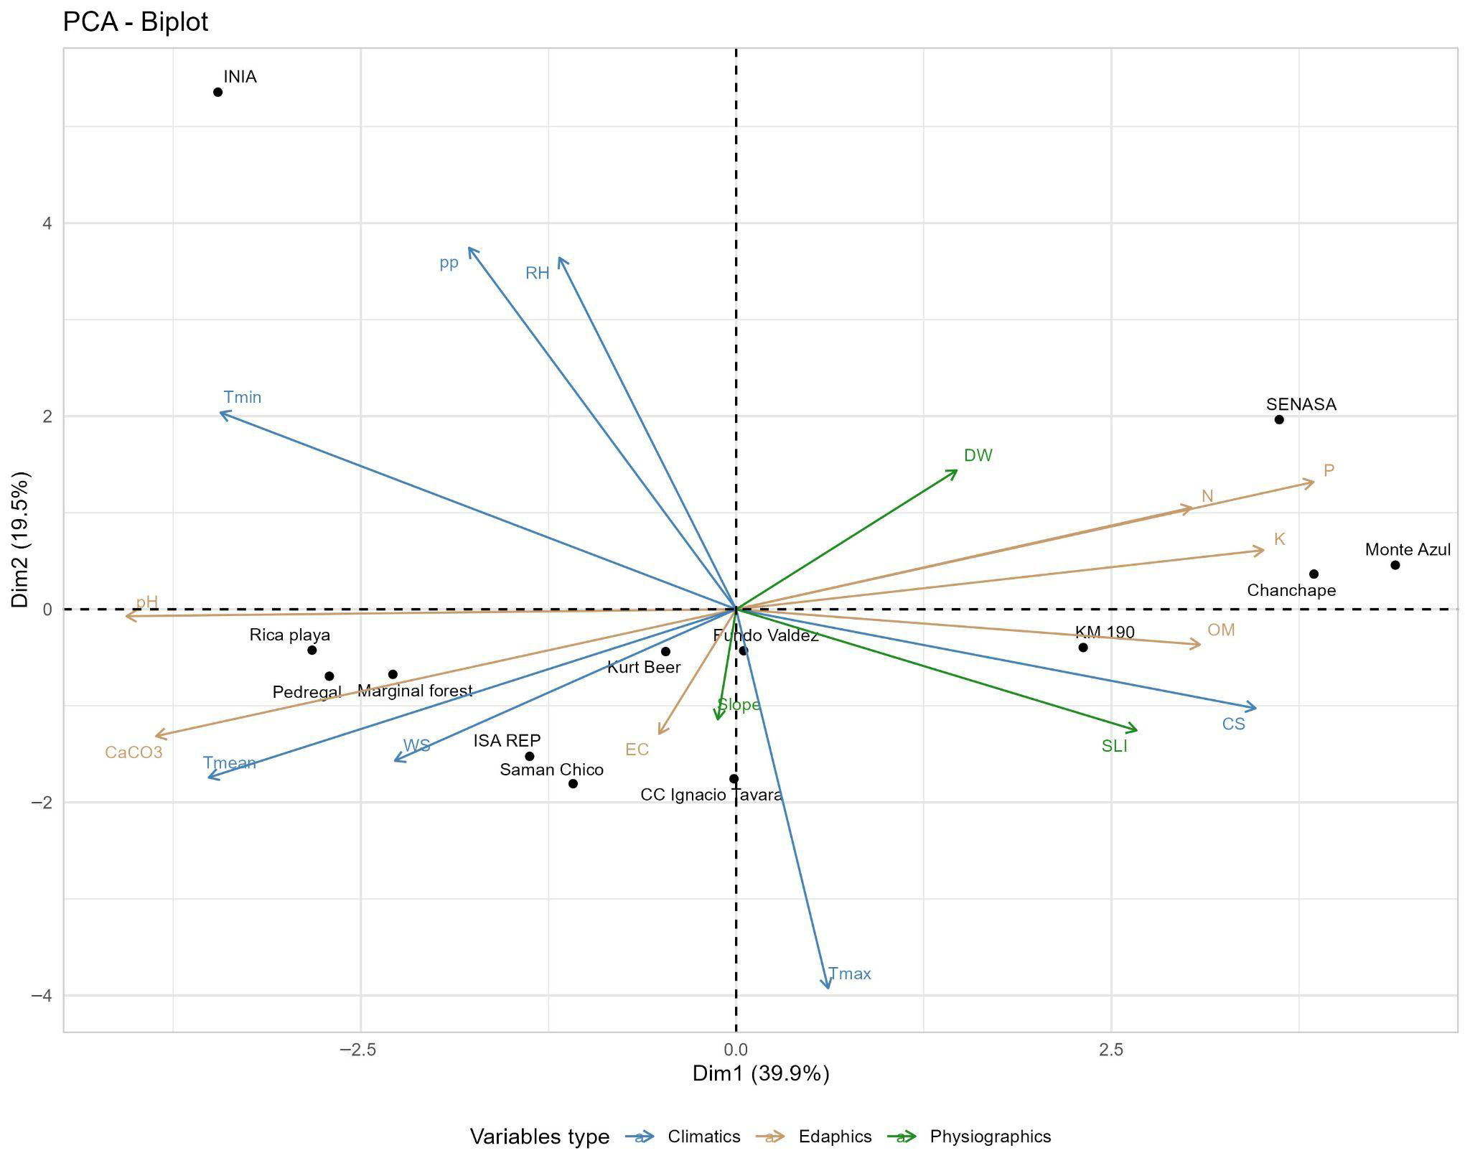

**Figure 2.** Principal component analysis (PCA) of edaphoclimatic properties in *N. pallida* populations evaluated in the departments of Piura and Tumbes. Projection of edaphoclimatic variables and study localities onto the first two principal components, which together explain the largest proportion of total system variance (*n* = 631). Description of environmental variables: Calcium carbonate (CaCO3, %), Electrical conductivity (EC, dS/m), Phosphorus (P, ppm), Organic matter (OM, %), Nitrogen (N, %), Potassium (K, ppm), Potential of hydrogen (pH), Solar radiation (CS, MJ/m2/day), Precipitation (PP, mm/day), Relative humidity (RH, %), Mean temperature (Tmean, °C), Wind speed (WS, m/s), Maximum temperature (Tmax, °C), Minimum temperature (Tmin, °C), Elevation above sea level (SLI, m), Slope (Slope, %), and Euclidean distance to water bodies (DW, m).

3.2. Morphological Diversity

The phenotypic states, relative frequencies, and Shannon–Weaver diversity index (H′) values for the qualitative traits evaluated are presented in Table 4. Considerable polymorphism was observed across qualitative traits, revealing notable phenotypic variability within *N. pallida* populations. H′ values ranged from 0.55 to 1.30, with an overall mean of 1.01, indicating a high level of phenotypic diversity among the evaluated traits. This index reflects both the richness and evenness of phenotypic classes within each character.

The traits with the greatest diversity were fruit production (H′ = 1.30), tree form (H′ = 1.09), stem quality (H′ = 1.09), foliage quality (H′ = 1.07), and fruit quality (H′ = 1.00). All of these exceeded 1.0, suggesting a relatively even distribution across their phenotypic categories. In contrast, branching exhibited moderate phenotypic diversity, with a value of H′ = 0.55.

In terms of frequency distributions, tree form was dominated by individuals with intermediate morphology (37.88%), defined as trees with traits between a single stem with narrow branch angles (≤30°) and multistemmed forms with wider branching angles (>30°). For stem quality, the “moderate” class predominated (39.30%), representing trees with defects affecting 10–40% of the bole. Regarding fruit production, more than half of the trees evaluated (52.61%) did not produce fruits, while in fruit quality the “bitter” category was most frequent (53.41%). In foliage quality, the largest proportion of individuals (42.00%) exhibited foliage covering up to two-thirds of branches. Finally, branching showed a clear trend toward absence, with 83.04% of individuals lacking bifurcation.

**Table 4.** Phenotypic diversity of qualitative traits in *N. pallida* populations from Piura and Tumbes. Observed states of qualitative descriptors and Shannon–Weaver diversity index (H′) values are presented for each trait. Diversity levels were categorized as low (H′ = 0.10–0.40), intermediate (H′ = 0.40–0.60), and high (H′ > 0.60). The analysis was based on 631 observations (*n* = 631).

| **SN** | **Qualitative Traits** | **Shannon-Weaver Index** | **Descriptor’s States** | **Frequency** | **Proportion (%)** |
| --- | --- | --- | --- | --- | --- |
| 1 | Tree form | 1.09 | 1 = Multi-stemmed (<1.2 m) with branches > 30° | 195 | 30.9 |
|  |  |  | 2 = Intermediate | 239 | 37.88 |
|  |  |  | 3 = Single stem (<1.2 m) with branches ≤ 30° | 197 | 31.22 |
| 2 | Trunk quality | 1.09 | 1 = Defective | 195 | 30.9 |
|  |  |  | 2 = Fair with defects | 248 | 39.3 |
|  |  |  | 3 = No defects or only minor defects | 188 | 29.79 |
| 3 | Forking | 0.55 | 1 = Below DBH | 25 | 3.96 |
|  |  |  | 2 = At DBH | 82 | 13 |
|  |  |  | 3 = No forking | 524 | 83.04 |
| 4 | Fruit production | 1.3 | 0 = No fruits | 332 | 52.61 |
|  |  |  | 1 = Up to 25% of the branches | 93 | 14.74 |
|  |  |  | 2 = Up to 50% | 117 | 18.54 |
|  |  |  | 3 = Up to 75% | 52 | 8.24 |
|  |  |  | 4 = Up to 100% | 37 | 5.86 |
| 5 | Fruit quality | 1 | 0 = Very bitter | 337 | 53.41 |
|  |  |  | 1 = Bitter | 14 | 2.22 |
|  |  |  | 2 = Sweet | 223 | 35.34 |
|  |  |  | 3 = Very sweet | 57 | 9.03 |
| 6 | Foliage quality | 1.07 | 1 = Foliage on up to 1/3 of the branches | 139 | 22.03 |
|  |  |  | 2 = Up to 2/3 of the branches | 265 | 42 |
|  |  |  | 3 = Full foliage on all branches | 227 | 35.97 |

3.3. Phenotypic Diversity in Quantitative Traits

To evaluate phenotypic diversity in quantitative traits, variability was analyzed across localities. The results revealed pronounced heterogeneity in the performance of the dendrometric traits assessed, highlighting significant structural differences among *N. pallida* populations (Figure 3).

Analysis of diameter at breast height (DBH) showed significant differences among localities (*p* < 0.001). Fundo Valdez (50.07 cm), Monte Azul (46.62 cm), and KM 190 (45.77 cm) exhibited the highest mean values, indicating individuals with greater stem diameter development. In contrast, ISA REP (15.59 cm) and Rica Playa (16.06 cm) displayed the lowest values, reflecting populations with reduced bole thickness (Figure 3a).

For total tree height, statistically significant differences were also detected among localities (*p* < 0.001). The tallest individuals were recorded at Monte Azul (14.44 m), Fundo Valdez (12.33 m), and Saman Chico (11.40 m), while ISA REP (4.67 m) and Rica Playa (7.95 m) presented the shortest trees (Figure 3b).

Crown diameter likewise exhibited significant variability across localities (*p* < 0.001). Monte Azul (14.42 m), Saman Chico (14.25 m), and CC Ignacio Távara (14.02 m) had the largest average crown diameters, reflecting individuals with broader architectures and potentially greater dominance. Conversely, ISA REP (6.04 m) and SENASA (6.68 m) displayed the smallest crowns (Figure 3c).

Finally, for height to the first branching, significant differences were observed among localities (*p* < 0.001). Fundo Valdez (4.08 m), SENASA (3.21 m), and Monte Azul (3.20 m) recorded the greatest branching heights, suggesting trees with cleaner boles. In contrast, ISA REP (1.32 m) and Chanchape (1.71 m) exhibited the lowest values (Figure 3d).

Hierarchical cluster analysis, based on the combination of qualitative and quantitative traits previously evaluated, grouped the 13 study localities into four distinct clusters. This classification reflects patterns of phenotypic variation in *N. pallida* populations, highlighting relationships between structural and functional traits of individuals and their geographic origin. This clustering reflects patterns in the phenotypic variation in N*. pallida* populations. (Figure 4).

Cluster I included the localities Saman Chico and Monte Azul, distinguished by individuals with the highest average values of DBH (37.33 cm and 46.62 cm, respectively), total height (11.40 m and 14.44 m), and crown diameter (14.25 m and 14.42 m). These trees also exhibited high fruit production, with very sweet fruits, and dense foliage providing full branch coverage.

Cluster II comprised the localities Kurt Beer, Chanchape, and Fundo Valdez. This group displayed intermediate DBH values (33.63 cm, 34.20 cm, and 50.07 cm, respectively), total heights ranging from 9.77 m to 12.33 m, and crown diameters between 10.50 m and 12.40 m. Qualitatively, trees in this group bore fruits distributed across up to 75% of branches, accompanied by dense foliage covering two-thirds to the entirety of branches.

Cluster III was formed by the localities Marginal Forest, Pedregal, CC Ignacio Távara, and KM 190. This group was characterized by individuals with relatively high DBH values, ranging from 30.81 cm (Pedregal) to 45.77 cm (KM 190). Total heights remained intermediate (8.49–11.13 m), while crown diameters varied between 8.30 m and 14.02 m. Qualitatively, trees presented fruits distributed across 25–50% of branches, with flavors ranging from sour to sweet, and partial foliage coverage limited to two-thirds of branches.

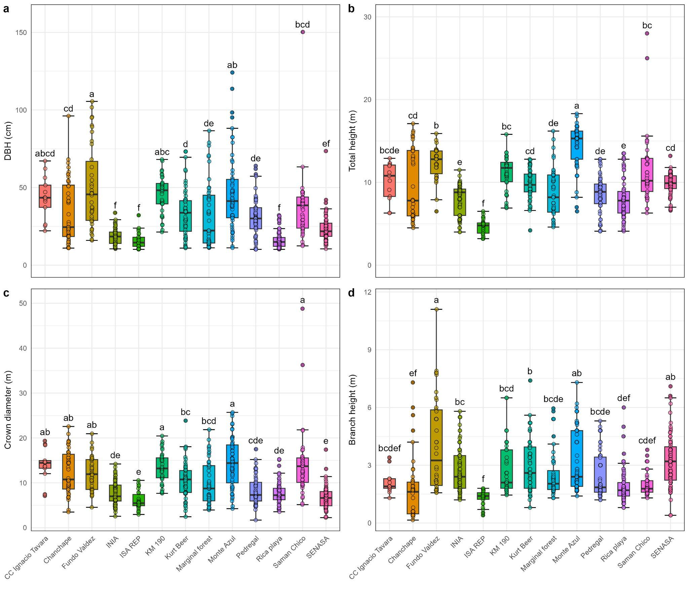

**Figure 3.** Distribution of quantitative morphological traits in *N. pallida* populations evaluated across 13 localities in the departments of Piura and Tumbes. (**a**) Diameter at breast height (cm, DBH). (**b**) Total height (m). (**c**) Crown diameter (m). (**d**) Height to the first branching (m). Distributions are based on the evaluation of 631 individuals, allowing the characterization of phenotypic variability among localities and providing inputs for germplasm conservation and selection. Different letters indicate statistically significant differences according to Tukey’s multiple comparison test (*p* < 0.05).

Cluster IV included the localities INIA, Rica Playa, ISA REP, and SENASA, which grouped individuals with the lowest average values for all evaluated traits. DBH ranged from 15.59 cm (ISA REP) to 23.59 cm (SENASA), total height varied between 4.67 m and 9.80 m, and crown diameter between 6.04 m and 7.66 m. These localities were also characterized by low fruit production, frequent stem defects, sparse or low-quality foliage, and a predominance of bitter-tasting fruits.

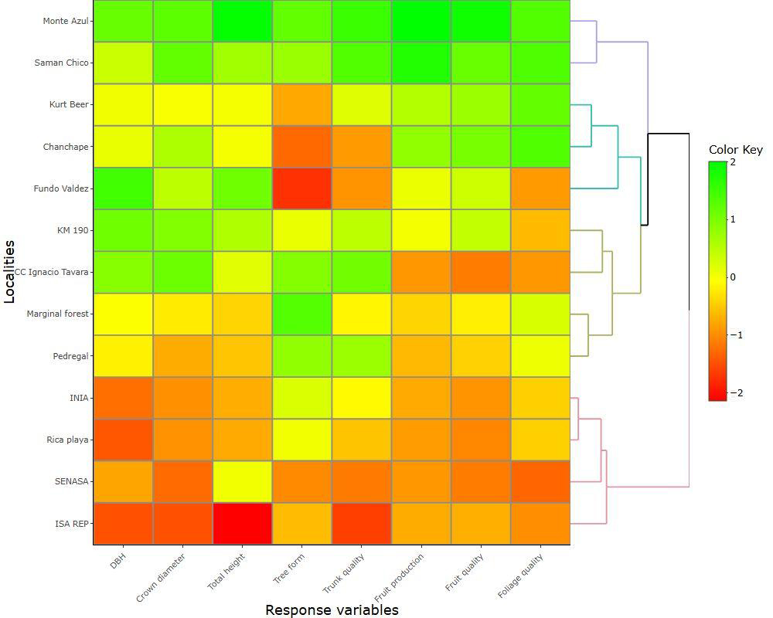

**Figure 4.** Cluster analysis of 13 *N. pallida* localities evaluated in the departments of Piura and Tumbes. Clustering was performed using Euclidean distance as the dissimilarity measure and the Weighted Pair Group Method using Centroids (WPGMC). The optimal number of clusters was determined using the average silhouette coefficient, allowing the identification of locality groups with similar morphological and phenotypic characteristics. Description variables evaluated: Diameter at breast height (cm, DBH), Crown diameter (m), Total height (m), Tree form (1–3 scale), Trunk quality (1–3 scale), Fruit production (0–4 scale), Fruit quality (0–3 scale), Foliage quality (1–3 scale).

3.4. Assess Population Differentiation in Phenotypic Traits and Tree Selection

Understanding the genetic improvement potential of *N. pallida* in the regions of Piura and Tumbes requires quantifying the proportion of phenotypic variation attributable to genetic versus environmental effects. In this study, we conducted a phenotypic characterization of 631 adult individuals distributed across 13 natural populations located in both regions. The sampled populations included CC Ignacio Távara (*n* = 13), Chanchape (*n* = 44), Fundo Valdez (*n* = 38), INIA (*n* = 81), ISA REP (*n* = 26), KM 190 (*n* = 36), Kurt Beer (*n* = 55), Marginal Forest (*n* = 44), Monte Azul (*n* = 56), Pedregal (*n* = 52), Rica Playa (*n* = 71), Saman Chico (*n* = 41), and SENASA (*n* = 74). To determine whether the observed phenotypic differentiation among populations reflects neutral divergence or adaptive processes, we quantified the degree of phenotypic differentiation ($P_{ST}$) across nine functional traits and compared these values with the neutral genetic differentiation ($F_{ST}$). This approach allowed us to infer the relative contributions of selection and drift to population divergence and to assess the adaptive potential of *N. pallida* in heterogeneous arid environments.

The sensitivity analysis of phenotypic differentiation ($P_{ST}$) with respect to the ratio $c/h^{2}$ revealed consistently high levels of divergence among populations of *N. pallida* for all quantitative traits evaluated (Figure 5). Across the nine traits, the $P_{ST}$ values increased sharply at low $c/h^{2}$ values (<1.0) and reached asymptotic plateaus above 0.8–0.9, indicating that phenotypic differentiation remained robust even under conservative assumptions of additive genetic variance and heritability. For all traits, the estimated $P_{ST}$ curves (solid red lines) lay well above the neutral genetic differentiation threshold ($F_{ST}=0.03$; green dashed line) throughout the explored range of $c/h^{2}$ (Figure 5). This pattern demonstrates that phenotypic divergence between populations substantially exceeds the level expected under genetic drift alone.

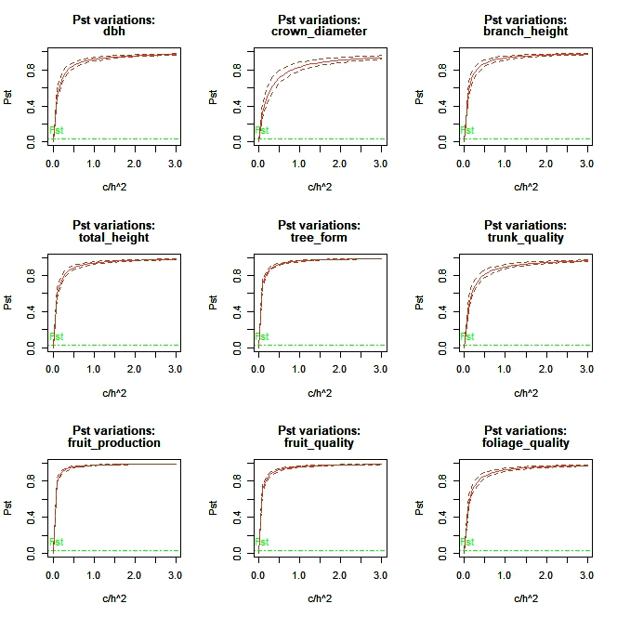

**Figure 5.** Sensitivity of phenotypic differentiation ($P_{ST}$) to the ratio $c/h^{2}$ for nine quantitative traits in *N. pallida*. Solid red lines represent the estimated $P_{ST}$ values and dashed red lines indicate the 95% bootstrap confidence intervals obtained from 1000 resamples. The green dashed line denotes the neutral genetic differentiation ($F_{ST}=0.03$) reported for the species Chequer et al., [50]. Traits include growth (DBH, crown diameter, branch height, total height), stem and architectural quality (tree form, trunk quality), and reproductive or foliar traits (fruit production, fruit quality, foliage quality).

Growth-related traits such as DBH, crown diameter, branch height, and total height showed $P_{ST}$ values between 0.83 and 0.94 (Table 5), with narrow 95% confidence intervals, indicating moderate-to-high differentiation and likely adaptation to local environmental conditions such as soil moisture and temperature. Architectural and stem-quality traits (tree form and trunk quality) exhibited even higher differentiation ($P_{ST}>0.95$). Reproductive and foliar traits (fruit production, fruit quality, and foliage quality) also showed elevated $P_{ST}$ values (0.92–0.98), suggesting the influence of divergent selective forces linked to reproductive output, seed dispersal, or physiological adaptation to water deficit. Among all variables, fruit production displayed the highest phenotypic differentiation ($P_{ST}=0.98$), indicating a potentially strong local adaptation of reproductive effort across environments.

**Table 5.** Phenotypic differentiation index ($P_{ST}$) and 95% bootstrap confidence intervals for nine quantitative traits in *N. pallida*. Values were estimated under the null assumption $c=h^{2}$ using 1000 bootstrap resamples. High $P_{ST}$ values relative to the neutral genetic differentiation ($F_{ST}=0.03$) indicate strong phenotypic divergence and suggest the action of divergent selection across populations.

| **Trait** | **Pst Values** | **95% Low Bound CI** | **95% Up Bound CI** |
| --- | --- | --- | --- |
| DBH | 0.92 | 0.90 | 0.94 |
| Crown diameter | 0.83 | 0.79 | 0.88 |
| Branch height | 0.93 | 0.91 | 0.95 |
| Total height | 0.94 | 0.93 | 0.95 |
| Tree form | 0.96 | 0.95 | 0.97 |
| Trunk quality | 0.90 | 0.87 | 0.93 |
| Fruit production | 0.98 | 0.97 | 0.98 |
| Fruit quality | 0.96 | 0.95 | 0.97 |
| Foliage quality | 0.93 | 0.91 | 0.95 |

A multivariate analysis was conducted, excluding variables with low contributions to explained variance. After preliminary evaluation, branching and branch height were removed due to their minimal influence on the multivariate structure of the dataset.

Principal component analysis (PCA) was then applied to explore phenotypic variability among individuals. The first two principal components explained 71.00% of the total system variance, with Dim 1 accounting for 54.30% and Dim 2 for 16.70%. In Dim 1, the variables contributing most to variance were crown diameter (15.75%), fruit production (15.02%), fruit quality (14.89%), and total height (14.29%). Dim 2 was mainly influenced by tree form (40.75%) and trunk quality (24.58%) (Figure 6).

The variable biplot showed clear groupings according to their contribution and orientation within the factorial space (Figure 6a). Three main associations were identified: (i) tree form and trunk quality aligned with Dim 2; (ii) DBH, total height, and crown diameter strongly correlated with Dim 1; and (iii) fruit production, fruit quality, and foliage quality, also associated with Dim 1 but positioned toward the positive quadrant of the axis (Figure 6a).

At the individual level, trees from Monte Azul, Samán Chico, and Fundo Valdez clustered in the region associated with higher values of DBH, total height, and crown diameter (Figure 6b). Monte Azul and Samán Chico were further distinguished by high fruit production, very sweet fruit quality, and excellent foliage quality, characterized by leaf coverage over the entirety of branches. In contrast, trees from Rica Playa, ISA REP, and SENASA occupied the opposite quadrant, associated with lower values of tree form and trunk quality (Figure 6b).

Outstanding trees were identified belonging to the locality of Monte Azul, La Matanza, Morropón—Piura. These individuals were distinguished by their high vigor, well-formed boles, strong fruiting capacity, and dense foliage cover. They met all favorable qualitative and quantitative selection criteria and displayed outstanding morpho-phenotypic expression compared with the rest of the population. Their superior attributes included abundant fruit production, vigorous biomass development, and close correspondence with favorable habitat conditions and conservation status.

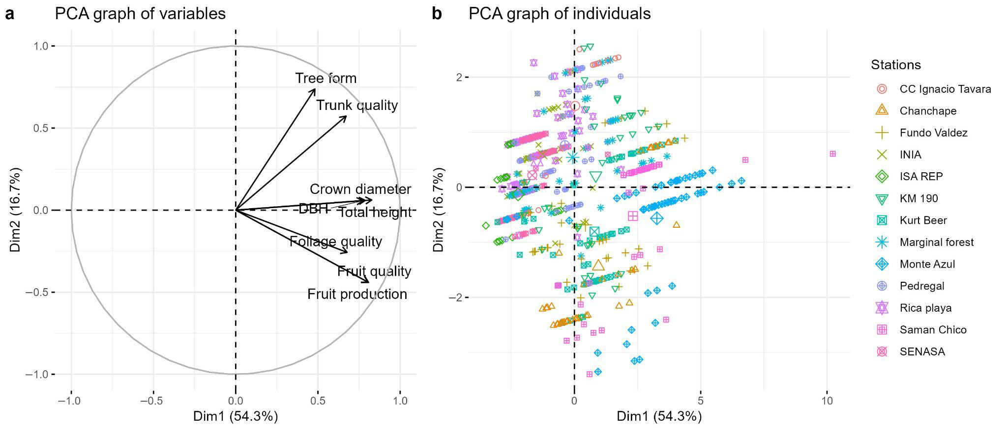

**Figure 6.** Principal component analysis (PCA) of morphological and phenotypic traits in *N. pallida* populations from Piura and Tumbes. (**a**) Projection of morphological and phenotypic variables onto the first two principal components, which explain the largest proportion of system variance. (**b**) Distribution of individuals grouped by locality in the multivariate space defined by the principal components, based on morphological and phenotypic characteristics. The analysis was conducted on 631 individuals (*n* = 631).

Quantitatively, the superior trees exhibited the highest values for the evaluated traits. Mean DBH reached 59.52 cm. Branching height ranged from 4.20 m to 6.20 m, substantially exceeding the population mean, which rarely surpassed 3 m. Total height averaged 16.05 m, considered optimal for fully developed individuals. Crown diameter averaged 15.83 m, reflecting a globose architecture with abundant biomass.

Qualitatively, all superior trees exhibited single stems with no bifurcations. Tree form was classified as dominant single-stemmed, while trunk quality was rated as “good,” meaning free of or with only minimal defects. All superior trees produced abundant fruits, distributed across 50–100% of branches, with fruits consistently rated as sweet to very sweet. Foliage quality was also outstanding, with leaf cover extending over at least two-thirds to the entirety of the branches.

4. Discussion

The present study analyzed the morphological and phenotypic diversity of *N. pallida* across 13 localities characterized by distinct edaphoclimatic conditions, where differences were found in soil fertility, climate, and topography. Our results reveal that the phenotypic traits of individuals from various localities in the departments of Piura and Tumbes exhibit a high degree of polymorphism, indicating genetic variability among the studied populations. In this context, heritability coefficients of the traits were estimated to identify those under greater genetic control and with higher potential for response to selection. As a result, individuals with superior phenotypes were identified as potential candidates for inclusion in a germplasm bank, aiming at their utilization in future breeding programs focused on the restoration and conservation of this species.

4.1. Edaphoclimatic Conditions

The edaphoclimatic analysis revealed marked differences in soil, climatic, and physiographic variables among the study sites (Figure 2), consistent with evidence that such factors influence vegetation distribution and development [51,52]. Soil variables exerted the strongest influence on the morpho-phenotypic expression of *N. pallida*. Monte Azul and Chanchape showed higher concentrations of N, P, K, and organic matter (OM), associated with more vigorous individuals, larger structural dimensions, and superior phenotypes in fruit production and foliage quality. By contrast, Rica Playa e ISA REP exhibited higher CaCO3 levels and alkaline pH, associated with unfavorable morpho-phenotypic traits. These patterns may be explained by phosphorus availability—often limiting in nutrient-poor soils [53]—as well as by organic matter, which improves both soil fertility and structure [54], and pH, which affects nutrient availability and microbial activity [55,56].

This evidence supports the hypothesis that the reduced vigor observed in ISA REP and Rica Playa may be linked to salinity stress resulting from high CaCO3 content and elevated soil pH [57]. Similar responses were reported by Meglioli et al. [58], in *Neltuma flexuosa* and *N. chilensis,* where reductions in height and aboveground biomass under saline stress were observed, although tolerant individuals were also detected, suggesting a role for genetic variability. Samán Chico provides further evidence of this pattern, as despite high CaCO3 and electrical conductivity (EC), it contained well-developed individuals, suggesting potential genetic tolerance to salinity [59,60].

Climatic variables such as precipitation (pp), Tmin, and Tmean were slightly higher in Rica Playa, Pedregal, and Marginal forest, with lower relative humidity (RH), while Monte Azul and Chanchape presented intermediate values (Figure 2). Physiographic variables (e.g., distance to water bodies [DW], slope, and elevation [SLI]) showed no consistent influence on phenotypic traits. Although Pedregal, KM 190, and Fundo Valdez were closer to water bodies, and CC Ignacio Távara, KM 190, and Monte Azul were at higher elevations, these differences did not correlate with phenotypic variation. This aligns with Sadia et al. [61], who emphasized that edaphic factors such as pH, OM, P, and K availability are key determinants of plant distribution, but their effects must be understood in interaction with biotic and abiotic variables. Similarly, Barboza et al. [8] identified climatic variables (mean temperature of the wettest quarter, maximum temperature of the warmest month, elevation, and annual precipitation) as critical for *N. pallida* suitability, but in our study the relative climatic homogeneity reduced their influence. These findings are consistent with Baselly-Villanueva et al. [62] and Rufasto-Peralta et al. [63], who observed that at local scales, edaphic variables are often more determinant than climatic or physiographic ones. Overall, the interaction between soil, environment, and genetic background must be considered in conservation, restoration, and breeding strategies for *N. pallida.*

4.2. Morphological Diversity in Algarrobo Populations

The morpho-phenotypic characterization revealed high polymorphism within and among populations in Piura and Tumbes (Table 4), suggesting considerable genetic diversity. The Shannon–Weaver diversity index (H′) showed high values, reflecting broad variability among traits [64,65]. Fruit production displayed the greatest diversity, whereas branching presented moderate diversity. Among dendrometric traits, analysis of variance indicated significant heterogeneity (Figure 3), suggesting structural differences among populations. Similar findings were reported by Bessega et al. [66] in *N. flexuosa*, where differences in height and basal diameter were partly genetically based but modulated by local environmental conditions. Likewise, Vega et al. [67] argued that *N. alba* exhibits strong adaptive capacity to environmental heterogeneity, favoring local adaptation processes.

Our results are also consistent with Esparza-Orozco et al. [68], who identified significant phenotypic differences among *Neltuma* populations associated with geographic origin. These findings suggest that phenology and morphology in this genus are strongly influenced by ecological factors. Vidaković et al. [69] further emphasized that interactions between environment and geography can explain observed phenotypic variation, reflecting potential processes of isolation by environment and by distance. In our study, Monte Azul, Chanchape, and Samán Chico (Piura) were distinguished by superior morphological and phenotypic performance, while Rica Playa, ISA REP, and SENASA (Tumbes) were associated with lower performance. This pattern supports the hypothesis of simultaneous environmental and geographic isolation shaping genetic and phenotypic structuring in *N. pallida* populations. According to Wang et al. [70], high phenotypic variation often reflects high genetic diversity; thus, phenotypic evaluation represents a direct and effective approach for estimating diversity in forest germplasm resources.

4.3. Population Differentiation and Identification of Superior Trees

The consistent pattern of high phenotypic differentiation ($P_{ST}$) across all evaluated traits in *N. pallida* indicates that the morphological divergence among populations cannot be explained solely by neutral processes such as genetic drift (Figure 5). The magnitude of $P_{ST}$ greatly exceeding $F_{ST}$ (0.03; Castillo et al., [71]) supports the hypothesis that adaptive differentiation has occurred under heterogeneous selection pressures associated with environmental gradients of aridity, soil texture, and local management regimes. Similar evidence has been reported for other species within the *Prosopis complex*, such as *P. chilensis* and *P. flexuosa*, where phenotypic variation reflects a combination of environmental and evolutionary processes [50,72]. However, while *P. chilensis* shows low quantitative differentiation and signals of stabilizing selection due to ecological homogeneity, *N. pallida* exhibits stronger and more consistent divergence, suggesting that selection operates under more pronounced environmental contrasts or stronger directional pressures. The elevated $P_{ST}$ values for traits related to growth, tree architecture, and reproduction—particularly fruit production ($P_{ST}=0.98$) and tree form ($P_{ST}=0.96$)—indicate that these traits are likely under divergent selection, reflecting adaptation to site-specific ecological conditions and resource availability (Table 5).

These findings align with the adaptive framework proposed by Castillo et al., [71], who demonstrated that natural selection related to aridity, salinity, and biotic interactions has repeatedly driven adaptive radiation in the *Prosopis* lineage. The patterns observed in *N. pallida* reinforce the hypothesis that phenotypic evolution in this taxon is shaped by strong selection gradients acting on both structural and reproductive traits. High phenotypic differentiation coupled with low neutral genetic structure suggests that selection acts effectively despite potential gene flow among populations. Overall, the results point to a scenario of local adaptation and divergent selection in *N. pallida*, contrasting with the nearly neutral differentiation reported in *P. chilensis*. From a conservation and management perspective, maintaining population-level genetic diversity and local seed sources will be critical to preserving the adaptive potential of *N. pallida* in the face of increasing climatic and anthropogenic pressures.

Additionally, individuals with superior phenotypes belonging to the Monte Azul locality were identified, exhibiting outstanding characteristics in growth and pod production, thus representing the most promising material for inclusion in a germplasm bank. Nevertheless, considering the results obtained from populations such as Rica Playa and ISA REP, where lower mean values were recorded for morphological and phenotypic variables, it is important to emphasize that even in these less favorable environments, individuals with exceptional performance can be identified [73]. These specimens could be considered complementary candidates for selection, as their adaptation to more restrictive environmental conditions suggests the presence of genetic traits associated with tolerance and resilience to environmental stress [74]. The incorporation of individuals from marginal populations could strengthen the genetic base of breeding programs, contributing useful variability for ecological restoration in dry forest ecosystems.

Identification of superior trees was based on individual assessment, allowing the selection of outstanding trees in terms of fruit production, vegetative vigor, and crown architecture across 13 localities in Piura and Tumbes. Approximately 90% of individuals with superior traits were concentrated in these regions, consistent with Castro et al. [14]. While phenotypic selection was used here, comparisons with neighboring trees can further reduce microsite and age-related biases, increasing accuracy of genetic estimates [75]. Multivariate analyses confirmed that individuals from Monte Azul, Chanchape, and Samán Chico clustered in dimensions associated with higher productivity and biomass. Consolidating these candidates requires validation through progeny tests and clonal banks, as well as the integration of modern tools such as high-throughput phenotyping and genomic selection, which have proven effective in accelerating breeding cycles and mitigating G × E effects in forest programs [14,76]. The selected individuals provide a robust foundation for establishing seed orchards and germplasm banks, contributing to the productive and sustainable restoration of Peruvian dry forests.

4.4. Limitations and Perspectives

Despite the progress achieved in identifying superior individuals of *N. pallida*, questions remain as to whether the highlighted traits reflect a true genetic potential or are primarily influenced by local edaphoclimatic conditions and the age of the individuals. The heterogeneity in soil fertility, salinity levels, nutrient availability, and age differences among trees likely conditioned the phenotypic expression, creating the risk of overestimating individuals favored by environmental plasticity or advanced developmental stages, rather than by genuine genetic superiority. We acknowledge that quantitative parameters such as diameter and height can be influenced by the age of individuals. However, this study was conducted in natural forests of *N pallida*, where populations lack historical establishment records, making it impossible to determine the approximate age of trees through direct methods. In addition, it is acknowledged that the evaluation of fruit sweetness was performed organoleptically, which, although effective for field assessments, limits the quantitative comparison of soluble solid content among individuals.

In this context, it is recommended that future studies complement morpho-phenotypic selection with molecular marker analyses, progeny tests, and age estimations using dendrochronological techniques [77]. Incorporating this information will allow for a more precise distinction between genetic, environmental, and ontogenetic effects, thereby strengthening the interpretation of phenotypic variability. The integration of these approaches, combining genetic, environmental, and chronological information, will strengthen genetic improvement programs and ensure that the selected individuals not only express desirable traits under specific conditions but also maintain adaptive advantages, such as tolerance to abiotic stress and high growth potential, across diverse ecological scenarios.

5. Conclusions

The morpho-phenotypic characterization of *N. pallida* in the regions of Piura and Tumbes revealed substantial intra- and inter-population variability, reflected in the high degree of polymorphism observed. Edaphoclimatic differences among localities influenced the expression of evaluated traits, and the assessment of population differentiation using the $P_{ST}$ index showed high levels of phenotypic divergence among populations ($P_{ST}=0.83-0.98$), exceeding the reference neutral genetic differentiation ($F_{ST}=0.03$). This result indicates that the observed variation is largely driven by adaptive differentiation rather than neutral drift, suggesting that heterogeneous selection pressures associated with aridity, soil fertility, and local management practices have shaped population-level phenotypic structure**.** These findings led to the identification of superior individuals classified as elite trees, providing a foundation for the establishment of germplasm banks and the development of genetic improvement programs aimed at the conservation and ecological restoration of this species within tropical dry forest ecosystems.

**Supplementary Materials:** The following supporting information can be downloaded at https://www.mdpi.com/article/doi/s1, Supplementary Materials: ESM_1.

**Author Contributions:** Conceptualization, W.N.; methodology, S.C.-N., J.R.B.-V., E.J.S.-H., S.Y.C.-V., and W.N.; formal analysis, S.C.-N. and F.L.-I.; investigation, W.N. and N.T.T.; data curation, S.C.-N. and F.L.-I.; writing—original draft preparation, S.C.-N., J.R.B.-V., E.J.S.-H., S.Y.C.-V., N.T.T., and F.L.-I.; writing—review and editing, F.L.-I.; visualization, S.C.-N. and F.L.-I.; software, S.C.-N. and F.L.-I.; resources, M.R.R.; project administration, M.R.R.; funding acquisition, M.R.R. All authors have read and agreed to the published version of the manuscript.

**Funding:** This work was funded by the National Institute of Agricultural Innovation (INIA), Peru, through investment project No. 2472190 “El Chira”.

**Data Availability Statement:** The original contributions presented in this study are included in the article and its supplementary material. Reproducible datasets and data analysis scripts are provided in Supplementary Materials and are publicly accessible via the GitHub repository at: https://github.com/Sebass96/INIA_algarrobo (accessed on 13 October 2025).

**Acknowledgments:** The authors would like to thank the Directorate of Studies and Research of the National Forest and Wildlife Service (SERFOR), Peru, for their valuable support during field data collection. We also thank Professor Milagros Ninoska Muñoz-Salas for her valuable assistance in translating the manuscript into English.

**Conflicts of Interest:** The authors declare no conflicts of interest.

**References**

1. Hughes,C.E.;Ringelberg,J.J.;Lewis,G.P.;Catalano,S.A.DisintegrationoftheGenus *Prosopis* L.(Leguminosae,Caesalpinioideae,MimosoidClade). *PhytoKeys* **2022**, *205*,147–189.https://doi.org/10.3897/phytokeys.205.75379.
2. Bessega,C.;Saidman,B.O.;Darquier,M.R.;Ewens,M.;Sánchez,L.;Rozenberg,P.;Vilardi,J.C.ConsistencybetweenMarker-andGenealogy-BasedHeritabilityEstimatesinanExperimentalStandof *Prosopis alba* (Leguminosae). *Am. J. Bot.* **2009**, *96*,458–465.https://doi.org/10.3732/ajb.0800074.
3. Grados,N.;Cruz,G.;Albán,L.;Felker,P.Peruvian *Prosopis pallida*:ItsPotentialtoProvideHumanandLivestockFoodforTropicalAridLandsoftheWorld.In *Prosopis as a Heat Tolerant Nitrogen Fixing Desert Food Legume*;Puppo,M.C.,Felker,P.,Eds.;AcademicPress:Cambridge,MA,USA,2022;pp.241–251,ISBN978-0-12-823320-7.
4. Beresford-Jones,D.G.;Arce,S.T.;Whaley,O.Q.;Chepstow-Lusty,A.J.TheRoleof *Prosopis* inEcologicalandLandscapeChangeintheSamacaBasin,LowerIcaValley,SouthCoastPerufromtheEarlyHorizontotheLateIntermediatePeriod. *Lat. Am. Antiq.* **2009**, *20*,303–332.https://doi.org/10.1017/S1045663500002650.
5. Beresford-Jones,D.G.;Whaley,O.Q. *Prosopis* intheHistoryoftheCoastofPeru.In *Prosopis as a Heat Tolerant Nitrogen Fixing Desert Food Legume*;Puppo,M.C.,Felker,P.,Eds.;AcademicPress:Cambridge,MA,USA,2022;pp.95–103,ISBN978-0-12-823320-7.
6. Duval,V.S.;Cámara-Artigas,R.Diversidadycapturadecarbonoenunbosquesecundariodecaldén(*Prosopis caldenia*)enLaPampa,Argentina. *Estud. Geográficos* **2021**, *82*,e073.https://doi.org/10.3989/estgeogr.202184.084.
7. Salazar,P.C.;Navarro-Cerrillo,R.M.;Ancajima,E.;DuqueLazo,J.;Rodríguez,R.;Ghezzi,I.;Mabres,A.EffectofClimateandENSOEventson *Prosopis pallida* ForestsalongaClimaticGradient. *Forestry* **2018**, *91*,552–562.https://doi.org/10.1093/forestry/cpy014.
8. Barboza,E.;Bravo,N.;Cotrina-Sanchez,A.;Salazar,W.;Gálvez-Paucar,D.;Gonzales,J.;Saravia,D.;Valqui-Valqui,L.;Cárdenas,G.P.;Ocaña,J.;etal.ModelingtheCurrentandFutureHabitatSuitabilityof *Neltuma Pallida* intheDryForestofNorthernPeruunderClimateChangeScenariosto2100. *Ecol. Evol.* **2024**, *14*,e70158.https://doi.org/10.1002/ece3.70158.
9. Vera,E.;Cruz,C.;Barboza,E.;Salazar,W.;Canta,J.;Salazar,E.;Vásquez,H.V.;Arbizu,C.I.ChangeofVegetationCoverandLandUseofthePómacForestHistoricalSanctuaryinNorthernPeru. *Int. J. Environ. Sci. Technol.* **2024**, *21*,8919–8930.https://doi.org/10.1007/s13762-024-05597-6.
10. LaTorre,R.;Hamilton,J.P.;Saucedo-Bazalar,M.;Caycho,E.;Vaillancourt,B.;Wood,J.C.;Ramírez,M.;Buell,C.R.;Orjeda,G.AChromosome-LevelGenomeAssemblyofthePeruvianAlgarrobo(*Neltuma pallida*)ProvidesInsightsonItsAdaptationtoItsUniqueEcologicalNiche. *G3 Genes Genomes Genet.* **2025**, *15*,jkae283.https://doi.org/10.1093/g3journal/jkae283.
11. Rosales-Islas,E.;Barrera-Tello,D.;Sánchez-González,A.;Galván-Hernández,D.M.;Hernández-León,S.;Octavio-Aguilar,P.Caracterizaciónmorfológicaygenéticadelaspoblacionesde *Abies* enHidalgo,México:Importanciadelaidentidadtaxonómicaparaelaprovechamientoforestal. *Bot. Sci.* **2023**, *101*,417–434.https://doi.org/10.17129/botsci.3203.
12. Bessega,C.;Pometti,C.;Ewens,M.;Saidman,B.O.;Vilardi,J.C.EvidencesofLocalAdaptationinQuantitativeTraitsin *Prosopis alba* (Leguminosae). *Genetica* **2015**, *143*,31–44.https://doi.org/10.1007/s10709-014-9810-5.
13. Castañeda-Garzón,S.L.;Argüelles-Cárdenas,J.H.;Zuluaga-Peláez,J.J.;Moreno-Barragán,J.Evaluacióndelavariabilidadfenotípicaen *Simarouba amara* Aubl.,mediantedescriptorescualitativosycuantitativos. *Orinoquia* **2021**, *25*,67–77.https://doi.org/10.22579/20112629.656.
14. Castro,W.;Seminario,R.;Nauray,W.;Acevedo-Juárez,B.;De-la-Torre,M.;Avila-George,H.MultispectralDroneImageryDatasetforplusandNon-plus *Neltuma Pallida* TreesinNorthernPeru. *Data Brief* **2025**, *60*,111645.https://doi.org/10.1016/j.dib.2025.111645.
15. Ipinza,R.;Gutiérrez,B.;Emhart,V. *Mejora Genética Forestal Operativa*;UniversidadAustraldeChile:Valdivia,Chile,1998;ISBN978-956-288-072-5.
16. Tomback,D.F.;Keane,R.E.;Schoettle,A.W.;Sniezko,R.A.;Jenkins,M.B.;Nelson,C.R.;Bower,A.D.;DeMastus,C.R.;Guiberson,E.;Krakowski,J.;etal.TammReview:CurrentandRecommendedManagementPracticesfortheRestorationofWhitebarkPine(*Pinus albicaulis* Engelm.),anImperiledHigh-ElevationWesternNorthAmericanForestTree. *For. Ecol. Manag.* **2022**, *522*,119929.https://doi.org/10.1016/j.foreco.2021.119929.
17. Zobel,B.;Talbert,J. *Applied Forest Tree Improvement*;Caldwell,N.J.,Ed.;BlackburnPress:Caldwell,NJ,USA,1984;ISBN978-1-930665-81-1.
18. Alban,L.;Matorel,M.;Romero,J.;Grados,N.;Cruz,G.;Felker,P.CloningofElite,MultipurposeTreesofthe *Prosopis juliflora/pallida* ComplexinPiura,Peru. *Agrofor. Syst.* **2002**, *54*,173–182.https://doi.org/10.1023/A:1016093106338.
19. Salazar,W.;Cruz-Grimaldo,C.;Lastra,S.;Rengifo,R.;Vargas-de-la-Cruz,C.;Godoy-Padilla,D.;Sessarego,E.;Cruz,J.;Solórzano,R.NutritionalQualityofthe“Algarrobo” *Neltuma pallida* FruitandItsRelationshipwithSoilPropertiesandVegetationIndicesintheDryForestsofNorthernPeru. *Sustainability* **2025**, *17*,8296.https://doi.org/10.3390/su17188296.
20. Grados,N.;Cruz,G.;Albán,L.;Felker,P.Peruvian *Prosopis pallida*:ItsPotentialtoProvideHumanandLivestockFoodforTropicalAridLandsoftheWorld.In *Prosopis as a Heat Tolerant Nitrogen Fixing Desert Food Legume*;Puppo,M.C.,Felker,P.,Eds.;AcademicPress:Cambridge,MA,USA,2022;pp.241–251,ISBN978-0-12-823320-7.
21. Castañeda-Garzón,S.L.;Arenas-Rubio,I.;Argüelles-Cárdenas,J.H.;Montero-Cantillo,Y.D.;Gutiérrez-Berdugo,I.A.;Zuluaga-Peláez,J.J.Caracterizacióndeunaplantaciónjuvenilde *Cavanillesia platanifolia* enlaZonaBananeraColombiana. *Madera Bosques* **2023**, *29*,e2922495.https://doi.org/10.21829/myb.2023.2922495.
22. ParedesUlloa,C.O.;Viafara,D.;Dueñas,Y.D.;VillaltaMazabanda,B.A.V.;MachadoCuzco,J.A.;ReyesMera,J.J.CaracterizacióneIdentificacióndeEspeciesForestalesNativascomoFuentesdeSemillaenlaAmazoníaEcuatoriana. *Cienc. Lat. Rev. Científica Multidiscip.* **2025**, *9*,3242–3258.https://doi.org/10.37811/cl_rcm.v9i2.17136.
23. LópezLauenstein,D.;Vega,C.;Verga,A.;Lascano,H.R.;Marchelli,P.LocalAdaptativeStrategiesforCopingwithDroughtStressin *Neltuma alba* (Leguminosae,Caesalpinioideae)AreAssociatedwiththeTimingofLeafSenescence. *New For.* **2025**, *56*,28.https://doi.org/10.1007/s11056-025-10096-8.
24. O’Reilly-Wapstra,J.M.;Miller,A.M.;Hamilton,M.G.;Williams,D.;Glancy-Dean,N.;Potts,B.M.ChemicalVariationinaDominantTreeSpecies:PopulationDivergence,SelectionandGeneticStabilityacrossEnvironments. *PLoS ONE* **2013**, *8*,e58416.https://doi.org/10.1371/journal.pone.0058416.
25. Whitlock,M.C.EvolutionaryInferencefromQST. *Mol. Ecol.* **2008**, *17*,1885–1896.https://doi.org/10.1111/j.1365-294X.2008.03712.x.
26. Brommer,J.E.WhitherPst?TheApproximationofQstbyPstinEvolutionaryandConservationBiology. *J. Evol. Biol.* **2011**, *24*,1160–1168.https://doi.org/10.1111/j.1420-9101.2011.02268.x.
27. Power,D.A.V.NasaPower|DataAccessViewer(DAV).Availableonline:https://power.larc.nasa.gov/data-access-viewer/(accessedon22July2025).
28. Ministerio del Ambiente. *Ministerio del Ambiente Mapa Nacional de Ecosistemas del Perú*;Ministerio del Ambiente: Lima, Peru, 2019.
29. MacDicken,K.G.GlobalForestResourcesAssessment2015:What,WhyandHow? *For. Ecol. Manag.* **2015**, *352*,3–8.https://doi.org/10.1016/j.foreco.2015.02.006.
30. MinisteriodelAmbiente. *Guía de Inventario de la Flora y Vegetación*;MinisteriodelAmbiente:Lima,Peru,2015.
31. Roque,E.A.R.;BarrenaArroyo,V.M.;OcañaCanales,J.C.Tamañoóptimodeparceladeinventariosforestalesenbosquessecos(Lambayeque,Perú). *Cienc. Práct.* **2023**, *3(6)*.https://doi.org/10.52109/cyp2023649.
32. Carter,M.R.;Gregorich,E.G.(Eds.) *Soil Sampling and Methods of Analysis*,2nded.;CRCPress:BocaRaton,FL,USA,2007;ISBN978-0-429-12622-2.
33. *NOM-021-RECNAT-2000*;SpecificationsforSoilFertility,SalinityandClassification.SecretaríadeMedioAmbienteyRecursosNaturales(SEMARNAT):Mexico City, Mexico,2002.
34. Bayarri,S.;Costell,E.SensoryEvaluationofFruitandVegetableFlavors.In *Handbook of Fruit and Vegetable Flavors*;JohnWiley&SonsLtd.:Hoboken,NJ,USA,2010;pp.45–57,ISBN978-0-470-62283-4.
35. Lawless,H.T.;Heymann,H. *Sensory Evaluation of Food: Principles and Practices*;FoodScienceTextSeries;Springer:NewYork,NY,USA,2010;ISBN978-1-4419-6487-8.
36. Civille,G.V.;Carr,B.T.;Osdoba,K.E. *Sensory Evaluation Techniques*,6thed.;CRCPress:BocaRaton,FL,USA,2024;ISBN978-1-003-35208-2.
37. BlondeauDaSilva,S.;DaSilva,A.Pstat:AnRPackagetoAssessPopulationDifferentiationinPhenotypicTraits. *R J.* **2018**, *10*,447–454.https://doi.org/10.32614/RJ-2018-010.
38. Aitchison,J.TheStatisticalAnalysisofCompositionalData. *J. R. Stat. Soc. Ser. B (Methodol.)* **1982**, *44*,139–160.https://doi.org/10.1111/j.2517-6161.1982.tb01195.x.
39. Spitze,K.PopulationStructureinDaphniaObtusa:QuantitativeGeneticandAllozymicVariation. *Genetics* **1993**, *135*,367–374.https://doi.org/10.1093/genetics/135.2.367.
40. Merilä,J.;Crnokrak,P.ComparisonofGeneticDifferentiationatMarkerLociandQuantitativeTraits. *J. Evol. Biol.* **2001**, *14*,892–903.https://doi.org/10.1046/j.1420-9101.2001.00348.x.
41. RCoreTeam. *R: A Language and Environment for Statistical Computing*;RFoundationforStatisticalComputing:Vienna,Austria,2025.
42. Allaire,J.J.;Dervieux,C. *Quarto: R Interface to “Quarto” Markdown Publishing System*;CRAN:Wien, Austria,2025.https://doi.org/10.32614/CRAN.package.quarto.
43. Marcelo-Bazán,F.E.;Mantilla-Chávez,W.;Paredes-Pajares,K.P.;Chávez-Cercado,D.M.;Baselly-Villanueva,J.R.;Álvarez-Álvarez,P.IdentificationoftheOptimalSubstrateforSexualPropagationof *Cinchona officinalis* L.:ImplicationsforConservationandSustainableUse. *For. Sci.* **2025**, *71*,397–422.https://doi.org/10.1007/s44391-025-00018-8.
44. Husson,F.;Josse,J.;Le,S.;Mazet,J. *FactoMineR: Multivariate Exploratory Data Analysis and Data Mining*;CRAN:Wien, Austria,2024.https://doi.org/10.32614/CRAN.package.FactoMineR.
45. Kassambara,A.;Mundt,F. *Factoextra: Extract and Visualize the Results of Multivariate Data Analyses*;CRAN:Wien, Austria,2020.https://doi.org/10.32614/CRAN.package.factoextra.
46. Oksanen,J.;Simpson,G.L.;Blanchet,F.G.;Kindt,R.;Legendre,P.;Minchin,P.R.;O’Hara,R.B.;Solymos,P.;Stevens,M.H.H.;Szoecs,E.;etal. *Vegan: Community Ecology Package*;CRAN:Wien, Austria,2025.https://doi.org/10.32614/CRAN.package.vegan.
47. Lenth,R.V.;Bolker,B.;Buerkner,P.;Giné-Vázquez,I.;Herve,M.;Jung,M.;Love,J.;Miguez,F.;Piaskowski,J.;Riebl,H.;etal. *Emmeans: Estimated Marginal Means, Aka Least-Squares Means*;CRAN:Wien, Austria,2024.https://doi.org/10.32614/CRAN.package.emmeans.
48. Galili,T.;O’Callaghan,A.;Sidi,J.;Joo,J.;Benjamini,Y. *Heatmaply: Interactive Cluster Heat Maps Using “Plotly” and “Ggplot2”*;CRAN:Wien, Austria,2023.https://doi.org/10.32614/CRAN.package.heatmaply.
49. BlondeauDaSilva,S.;DaSilva,A. *Pstat: Assessing Pst Statistics*;CRAN:Wien, Austria,2017.
50. ChequerCharan,D.;Pometti,C.;Cony,M.;Vilardi,J.C.;Saidman,B.O.;Bessega,C.GeneticVarianceDistributionofSSRMarkersandEconomicallyImportantQuantitativeTraitsinaProgenyTrialof *Prosopis chilensis* (Leguminosae):Implicationsforthe‘Algarrobo’ManagementProgramme. *Forestry* **2021**, *94*,204–218.https://doi.org/10.1093/forestry/cpaa026.
51. Villagra,P.E.;Boninsegna,J.A.;Alvarez,J.A.;Cony,M.;Cesca,E.;Villalba,R.Dendroecologyof *Prosopis flexuosa* WoodlandsintheMonteDesert:ImplicationsforTheirManagement. *Dendrochronologia* **2005**, *22*,209–213.https://doi.org/10.1016/j.dendro.2005.05.005.
52. Yang,J.;Huang,Y.;Jiang,X.;Chen,H.;Liu,M.;Wang,R.PotentialGeographicalDistributionoftheEdangredPlant *Isoetes* underHumanActivitiesUsingMaxEntandGARP. *Glob. Ecol. Conserv.* **2022**, *38*,e02186.https://doi.org/10.1016/j.gecco.2022.e02186.
53. Jiang,J.;Wang,Y.-P.;Yang,Y.;Yu,M.;Wang,C.;Yan,J.InteractiveEffectsofNitrogenandPhosphorusAdditionsonPlantGrowthVarywithEcosystemType. *Plant Soil* **2019**, *440*,523–537.https://doi.org/10.1007/s11104-019-04119-5.
54. Hoffland,E.;Kuyper,T.W.;Comans,R.N.J.;Creamer,R.E.Eco-FunctionalityofOrganicMatterinSoils. *Plant Soil* **2020**, *455*,1–22.https://doi.org/10.1007/s11104-020-04651-9.
55. Neina,D.TheRoleofSoilpHinPlantNutritionandSoilRemediation. *Appl. Environ. Soil Sci.* **2019**, *2019*,5794869.https://doi.org/10.1155/2019/5794869.
56. Ni,Y.;Yang,T.;Ma,Y.;Zhang,K.;Soltis,P.S.;Soltis,D.E.;Gilbert,J.A.;Zhao,Y.;Fu,C.;Chu,H.SoilpHDeterminesBacterialDistributionandAssemblyProcessesinNaturalMountainForestsofEasternChina. *Glob. Ecol. Biogeogr.* **2021**, *30*,2164–2177.https://doi.org/10.1111/geb.13373.
57. Bello,S.K.;Alayafi,A.H.;AL-Solaimani,S.G.;Abo-Elyousr,K.A.M.MitigatingSoilSalinityStresswithGypsumandBio-OrganicAmendments:AReview. *Agronomy* **2021**, *11*,1735.https://doi.org/10.3390/agronomy11091735.
58. Meglioli,P.A.;Alvarez,J.A.;Lana,N.B.;Cony,M.A.;Villagra,P.E.SaltToleranceofNativeTreesRelevanttotheRestorationofDegradedLandscapesintheMonteRegion,Argentina. *Restor. Ecol.* **2025**, *33*,e14246.https://doi.org/10.1111/rec.14246.
59. Amin,I.;Rasool,S.;Mir,M.A.;Wani,W.;Masoodi,K.Z.;Ahmad,P.IonHomeostasisforSalinityToleranceinPlants:AMolecularApproach. *Physiol. Plant.* **2021**, *171*,578–594.https://doi.org/10.1111/ppl.13185.
60. Zhang,M.;Liu,Y.;Han,G.;Zhang,Y.;Wang,B.;Chen,M.SaltToleranceMechanismsinTrees:ResearchProgress. *Trees* **2021**, *35*,717–730.https://doi.org/10.1007/s00468-020-02060-0.
61. Sadia,S.;Waheed,M.;Firdous,S.;Arshad,F.;Fonge,B.A.;Al-Andal,A.EcologicalAnalysisofPlantCommunityStructureandSoilEffectsinSubtropicalForestEcosystem. *BMC Plant Biol.* **2024**, *24*,1275.https://doi.org/10.1186/s12870-024-06012-5.
62. Baselly-Villanueva,J.R.;Bazán,F.E.M.;Casas,G.G.;Lozano,A.I.L.;Castedo-Dorado,F.;Álvarez-Álvarez,P.Relacióndelosfactoresambientalesconlaproductividadde *Eucalyptus globulus* enlosAndesnorperuanos. *Bosque* **2024**, *45*,103–118.https://doi.org/10.4067/S0717-92002024000100103.
63. Rufasto-Peralta,Y.L.;Baselly-Villanueva,J.R.;Alva-Mendoza,D.M.;Seminario-Cunya,A.;Elera-Gonzales,D.G.;Villena-Velásquez,J.J.Estimacióndelacalidaddesitiode *Cinchona pubescens* (Rubiaceae),enelbosquemontanoLaPalma,Chota,Perú. *Lilloa* **2023**, *60*,259–279.https://doi.org/10.30550/j.lil/1826.
64. Sun,W.;Yuan,X.;Liu,Z.-J.;Lan,S.;Tsai,W.;Zou,S.-Q.MultivariateAnalysisRevealsPhenotypicDiversityof *Euscaphis japonica* Population. *PLoS ONE* **2019**, *14*,e0219046.https://doi.org/10.1371/journal.pone.0219046.
65. Yadav,R.K.;Gautam,S.;Palikhey,E.;Joshi,B.K.;Ghimire,K.H.;Gurung,R.;Adhikari,A.R.;Pudasaini,N.;Dhakal,R.Agro-MorphologicalDiversityofNepaleseNakedBarleyLandraces. *Agric. Food Secur.* **2018**, *7*,86.https://doi.org/10.1186/s40066-018-0238-5.
66. Bessega,C.;Cony,M.;Pometti,C.GeneticZonesof *Neltuma flexuosa*,theAlgarroboTreefromtheMonteDesertinArgentina. *For. Ecol. Manag.* **2025**, *586*,122715.https://doi.org/10.1016/j.foreco.2025.122715.
67. Vega,M.V.;Saidman,B.O.;Vilardi,J.C.;Vega,M.V.;Saidman,B.O.;Vilardi,J.C.SpatialStructureofPhenotypicTraitsinSevenProvenancesof *Neltuma alba* (Fabaceae). *Boletín Soc. Argent. Botánica* **2023**, *58*,6.https://doi.org/10.31055/1851.2372.v58.n4.39224.
68. Esparza-Orozco,A.;Carranza-Becerra,L.;Delgadillo-Ruiz,L.;BollaínyGoytia,J.J.;Gaytán-Saldaña,N.A.;Mandujano-García,C.D.;Delgadillo-Ruiz,E.;Michel-López,C.Y.;Huerta-García,J.;Valladares-Carranza,B.;etal.EnvironmentalHeterogeneityDrivesSecondaryMetaboliteDiversityfromMesquitePodsinSemiaridRegions. *Ecologies* **2025**, *6*,19.https://doi.org/10.3390/ecologies6010019.
69. Vidaković,A.;Liber,Z.;Šatović,Z.;Idžojtić,M.;Volenec,I.;Zegnal,I.;Pintar,V.;Radunić,M.;Poljak,I.PhenotypicDiversityofAlmond-LeavedPear(*Pyrus spinosa* Forssk.)alongEasternAdriaticCoast. *Forests* **2021**, *12*,1630.https://doi.org/10.3390/f12121630.
70. Wang,C.;Gong,H.;Feng,M.;Tian,C.PhenotypicVariationinLeaf,FruitandSeedTraitsinNaturalPopulationsof *Eucommia ulmoides*,aRelictChineseEndemicTree. *Forests* **2023**, *14*,462.https://doi.org/10.3390/f14030462.
71. Castillo,M.L.;Schaffner,U.;vanWilgen,B.W.;Montaño,N.M.;Bustamante,R.O.;Cosacov,A.;Mathese,M.J.;LeRoux,J.J.GeneticInsightsintotheGloballyInvasiveandTaxonomicallyProblematicTreeGenus *Prosopis*. *AoB PLANTS* **2021**, *13*,plaa069.https://doi.org/10.1093/aobpla/plaa069.
72. Darquier,M.R.;Bessega,C.F.;Cony,M.;Vilardi,J.C.;Saidman,B.O.EvidenceofHeterogeneousSelectiononQuantitativeTraitsof *Prosopis flexuosa* (Leguminosae)fromMultivariateQST–FSTTest. *Tree Genet. Genomes* **2013**, *9*,307–320.https://doi.org/10.1007/s11295-012-0556-x.
73. Ramírez-Valiente,J.A.;Solé-Medina,A.;Pyhäjärvi,T.;Savolainen,O.;Cervantes,S.;Kesälahti,R.;Kujala,S.T.;Kumpula,T.;Heer,K.;Opgenoorth,L.;etal.SelectionPatternsonEarly-LifePhenotypicTraitsin *Pinus sylvestris* AreAssociatedwithPrecipitationandTemperaturealongaClimaticGradientinEurope. *New Phytol.* **2021**, *229*,3009–3025.https://doi.org/10.1111/nph.17029.
74. Brancalion,P.H.S.;Oliveira,G.C.X.;Zucchi,M.I.;Novello,M.;vanMelis,J.;Zocchi,S.S.;Chazdon,R.L.;Rodrigues,R.R.PhenotypicPlasticityandLocalAdaptationFavorRangeExpansionofaNeotropicalPalm. *Ecol. Evol.* **2018**, *8*,7462–7475.https://doi.org/10.1002/ece3.4248.
75. Vallejos,J.;Badilla,Y.;Picado,F.;Murillo,O.Metodologíaparalaseleccióneincorporacióndeárbolesplusenprogramasdemejoramientogenéticoforestal. *Agron. Costarric.* **2010**, *34*,105–119.
76. Duarte,D.;Jurcic,E.J.;Dutour,J.;Villalba,P.V.;Centurión,C.;Grattapaglia,D.;Cappa,E.P.GenomicSelectioninForestTreesComestoLife:UnravelingItsPotentialinanAdvancedFour-Generation *Eucalyptus grandis* Population. *Front. Plant Sci.* **2024**, *15*,1462285.https://doi.org/10.3389/fpls.2024.1462285.
77. López,B.C.;Sabaté,S.;Gracia,C.A.;Rodríguez,R.WoodAnatomy,DescriptionofAnnualRings,andResponsestoENSOEventsof *Prosopis pallida* H.B.K.,aWide-SpreadWoodyPlantofAridandSemi-AridLandsofLatinAmerica. *J. Arid Environ.* **2005**, *61*,541–554.https://doi.org/10.1016/j.jaridenv.2004.10.008.

**Disclaimer/Publisher’s Note:** The statements, opinions and data contained in all publications are solely those of the individual author(s) and contributor(s) and not of MDPI and/or the editor(s). MDPI and/or the editor(s) disclaim responsibility for any injury to people or property resulting from any ideas, methods, instructions or products referred to in the content.